**NIT-3003**

**Secure Medical Records Portal-**

**(MediAccessHub)**

**Project Proposal: Opening Section**

**Group Members:**

**Member 1(Admin Portal): Md Mahmudul Hasan Saif**

**Member 1 ID: s8089637**

**Member 2 (Monitoring & Reports): Abyead Faisal Arnob**

**Member 2 ID: s8098828**

**Member 3(Doctor Portal): Tashfiqul Prodhan**

**Member 3 ID: s8116509**

**Member 4(Patient Portal): Prateek Maharjan**

**Member 4 ID: s8113219**

**Introduction**

**General Background (Prateek):**

In this modern world, healthcare has become more digitalized. Digital health is transforming how care is delivered around the world (World Health Organization, 2021). It has many important factors. One of them is how medical records are stored and shared. In past times, the records were written and stored on paper using different systems, which was not very convenient since it made it hard for doctors and patients to find or share important information quickly. Now, as the world is changing, it has been apparent that there is a strong need for a system that is secure, easy to use, and allows people to manage medical records online.  
Here we bring in our **MediAccessHub** which is a web-based portal that helps solve this problem. This platform helps doctors to update and manage their patient records without risking mixing up patients, dates etc. Also, patients could now view their health history and request appointments without worrying about missing appointments and forgetting dates, and admins manage users and system activity. The system we are to create is secure, with access controls that make sure each user can only see what they are allowed to.

**Market Analysis (Tashfiqul):**

We can see there is a growing need for these kinds of solutions as they decrease errors and help save lives in that area. The electronic health record market was valued at over $29 billion in 2023 and is expected to grow to $47.6 billion by 2030 (Fortune Business Insights, 2024). Recently, a lot of hospitals and medical centers already use digital systems, but some smaller clinics and private practices often don’t have access to simple and secure tools. MediAccessHub is designed to fill this gap.

**Competitor Analysis (Mahmudul Hasan):**

There are a lot of digital healthcare sites like my health record, practiceHub and Doxy.me, but each of them comes with a lot of limitations. These platforms assist healthcare providers and patients in many ways but fall short in terms of usability and functionality.

My Health Record allows users to link their medical history with Medicare. However, the system can be difficult for some users to navigate. PracticeHub is effective in managing clinic operations, compliance, and documentation. But it does not provide patients with direct access to their medical records. Doxy.me offers secure video consultations but lacks the capability to store or manage medical records for long-term use.

MediAccessHub is designed to overcome these limitations by offering a user-friendly, role-based system that allows doctors, patients and admins to manage, view and interact with medical data in a secure, accessible and integrated environment.

**Project Aims and Unique Selling Proposition (Arnob):**

Why is MediAccessHub better? We are different because our application is built around four user roles: doctors, patients, admins, and a system reporting module. All parts are designed and built by a different team member, including the front end, back end, database, and security. This makes the system well organized and easier to manage (Sommerville, 2016). By focusing on clear design and strong security, MediAccessHub offers a simple and modern way to handle medical records safely online.

**Summary:** our system offers these following things:

**Access based on roles and secure system (Saif):** There is a secure login system for every role assigned. Patients can view their medical history and make appointments; Doctors can update every patient's records. Admins look after the whole system and update the database. And the monitoring team monitors the system and makes reports.

**Centralized Medical record (Tashfiqul):** Doctor can manage and update patient data following the system structure and centralized platform. This highly reduces the risk of errors such as record duplication and ensuring data integrity and reliability.

**Patient Empowerment and Accessibility (Parteek):** Patients have full access to their medical history and their appointments, which are secure. This interface helps patients stay updated with their previous and ongoing records.

**Administrator Control and Oversight (Saif):** Admins manage user activities, update the system, and keep the system running smoothly.

**Intergrated System Reporting Module (Arnob):** Authorized users and admins monitor and report about the usage, appointment and records management enabling decision making which are driven by the data. The reports view current patterns of usage and also view traffic on the system.

## **Functional Requirements for MediAccessHub**

**Patient Portal – Functional Requirement (Prateek)**

## The main function of the patient portal is to be able to register into the portal, view their medical records while being able to download the data, request appointments with doctors and manage/request change in the appointment. The patients are allowed to login or register using their credentials i.e., Name, Email, contact no, Password and confirm password (For registration) and Email or username and password (For login).

The patient’s dashboard mainly contains greetings to the patients with two main features, like Registering oneself to the MediAccessHub portal, Medical Records with option to download data and Appointment Request and change the appointment details.

1. **Register a New Patient:**

* **Front-end:** The first step in registering an account is to accesses the registration page and fill out a form with fields like name, date of birth, email, phone, and password. Then the patient clicks on “Register” where all inputs are validated for format. The validated data is sent via POST request to the server.
* **Server-end:** On the server end, the server receives the registration data. It checks if the email already exists in the database. And If the data is valid, the server encrypts the password and stores the user record. Finally, the server sends a success or failure response to the front-end.
* **Database:**

|  |  |  |  |  |  |
| --- | --- | --- | --- | --- | --- |
| **Patient_ID** | **Full Name** | **Email** | **Phone** | **Password_hash** | **DOB** |
| **123** | **XX** | **XX** | **XX** | **XX** | **XX** |

1. **View Medical Records:**

* Front-end

Here, our patients are shown a list of their previous reports and their uploaded files in a table form. Every row displays report title, date, description and a Download file button. Everything displayed is accessed from the server when the page loads.

* Server-end

As the patient logs in the dashboard, the server identifies the patient by their e-mail and login credentials, then it displays their medical history and records.

* Database Tables

|  |  |  |  |  |  |  |
| --- | --- | --- | --- | --- | --- | --- |
| Record_id | Full Name | Patient_ email | Doctor_email | Title | Description | Date |
| 369 | XX XXX | XX | XX | Blood test | All normal | 03-02-2021 |

1. **Request Appointment:**

* Front-end

Users are allowed to access a form where they can Select a doctor, choose a date and time from calendar, write up their reason for appointment and click to submit button.

* Server-end

Here, the server is going to receive the data then verify the patient’s identity. Then it checks if the requested doctor exists and if the time slot is valid. If it is valid, then the appointment is kept in the database with a “Pending” status. An email or message is sent to the patient after confirmation.

Then the form is sent to the server using a secure post request.

* Database Tables

|  |  |  |  |  |  |  |
| --- | --- | --- | --- | --- | --- | --- |
| Appointment_ID | Full Name | Patient_email | Doctor_email | Appointment_date | Reason | Status |
| 246 | XX XXX | XX XXX | XX XXX | 10-10-2025; 10AM | Headache | Pending |

**Doctor Portal Component (Tashfiqul)**

**1. Introduction**

Key objectives of this system include providingsecure login and role-based access for patients, doctors, and administrators, and to enable doctors to manage availability, medical records, and appointments for their assigned patients. The system is designed around distinct user roles to ensure data privacy and ease of use. Its unique value lies in a modular development approach, allowing for a well-organized and highly secure platform that fills a gap in the market for smaller clinics and private practices

**2. Functional Requirements**

**1) Log in (Doctor - Tashfiqul)**

* **Function:** The system shall allow a doctor to log in using secure credentials.
* **Front-end:** A login form will be displayed with fields for the doctor's email and password. The user enters their credentials and clicks a "Login" button.
* **Server-end:** The server receives the credentials, hashes the provided password, and compares it against the stored hash in the database for the given email. Access is granted upon a match, and the user is redirected to the Doctor Dashboard.
* **Database:** Interacts with the Users table to verify credentials.

|  |  |  |  |  |
| --- | --- | --- | --- | --- |
| UserID | Email | FullName | HashedPassword | Role |
| 101 | [dr.smith@email.com](mailto:dr.smith@email.com) | John Smith | a9b1c7d3... | Doctor |
| 201 | [p.jones@email.com](mailto:p.jones@email.com) | Peter Jones | f4d8a25e... | Patient |

**2) View & manage records (Doctor - Tashfiqul)**

* **Function:** The system shall allow a Doctor to view, create, edit, and delete medical records for their assigned patients.
* **Front-end:** On a selected patient's record page, the system displays their medical history. Buttons for "Add New Record", "Edit", and "Delete" are available. A form is used for data entry.
* **Server-end:** Receives requests (POST, PUT, DELETE), validates data, confirms the doctor's authorization for the patient, and performs the corresponding database operation.
* **Database:** Interacts with the MedicalRecords table.

|  |  |  |  |  |  |
| --- | --- | --- | --- | --- | --- |
| RecordID | PatientID | DoctorID | Diagnosis | Notes | DateCreated |
| 5001 | 201 | 101 | Common Cold | Advised rest... | 2025-06-10 |

**3) Update availability (Doctor - Tashfiqul)**

* **Function:** The system shall allow a Doctor to set and update their available hours for appointments.
* **Front-end:** Displays a weekly calendar on a "My Availability" page. The doctor can click on a day to open a form to input their start and end times or mark the day as unavailable. Clicking "Save" sends the data to the server.
* **Server-end:** Receives availability data, validates it (e.g., start time is before end time), and saves or updates the entries for the specific doctor and date in the database.
* **Database:** Interacts with the DoctorAvailability table.

|  |  |  |  |  |
| --- | --- | --- | --- | --- |
| AvailabilityID | DoctorID | AvailableDate | StartTime | EndTime |
| 1 | 101 | 2025-06-16 | 9:00:00 | 17:00:00 |

**4) View scheduled appointments (Doctor - Tashfiqul)**

* **Function:** The system shall allow a doctor to view their upcoming scheduled appointments.
* **Front-end:** Displays a weekly or monthly calendar view showing all the doctor's scheduled appointments. Each entry shows the patient's name and appointment time.
* **Server-end:** Queries the database for all appointments linked to the doctor's ID and provides the data to the front-end calendar component.
* **Database:** Interacts with the Appointments table.

|  |  |  |  |  |
| --- | --- | --- | --- | --- |
| AppointmentID | PatientID | DoctorID | AppointmentDate | Status |
| 801 | 202 | 101 | 2025-06-18 10:00 | Confirmed |

**Admin Portal – Functional Requirements (Saif)**

The admin portal provides admin with a secure login and dashboard interface. This portal allows the admin to view the full list of user accounts and status. The admin should have access to manage and view Doctor and patient profiles for database updates.

And the Admin portal makes sure there is admin only access to sensitive data.

1. **Admin Login**
   1. **Front-End:** Admin Login Page:
      1. Admin Email
      2. Admin Password
      3. Sign in button for admin
      4. Forgot password? Button for admin
   2. **Back-End:**
      1. POST/admin/login
      2. Verify admin login credentials
      3. Generate session for admin
      4. Show admin dashboard upon successful login
   3. **Database:**

|  |  |  |
| --- | --- | --- |
| Admin ID | Email | Password |
| 1 | xxx | xxx |

1. **Manage Doctor Registrations**
   1. **Front-End:** Admin dashboard will show all the registration request of doctors, and the table includes:
      1. Doctor Name
      2. Email
      3. Specialty
      4. Status
      5. Approve button
      6. Reject button
   2. **Back-End:**
      1. GET /admin/Doctors?Status=pending – view all pending reqeust
      2. PUT /admin/doctor/{id}/approve - Set status to approve
      3. PUT / admin/doctor/{id}/reject - Set status to rejected
   3. **Database:**

|  |  |  |  |  |
| --- | --- | --- | --- | --- |
| Doctor Name | Email | Specialty | Status | Is Active |
| xx | xx | xx | xx | xx |

1. **Manage User Profiles**
   1. **Front-End:** Admin Dashboard will show user management tab for both doctor and patient
      1. Doctor: ID, Name, Specialty, Email, Status [Edit][Deactivate]
      2. Patient: ID, Name, Email, Gender, Status [Edit][Deactivate]
   2. **Back-End:**
      1. GET /admin/user?Type=doctor | patient
      2. PUT /admin/user/{ID} - for updating info or to check is active
      3. Admin cannot delete user accounts only set status to inactive
   3. **Database:**

|  |  |  |  |  |
| --- | --- | --- | --- | --- |
| Doctor ID | Name | Specialty | Email | Status |
| xx | xx | xx | xx | xx |
| Patient ID | Name | Email | Gender | Status |
| xx | xx | xx | xx | xx |

1. **Create and Manage Doctor Schedule** 
   1. **Front-End:**
      1. Interface showing doctor availability
      2. List of available slots
      3. Admin selects slots to create schedule
      4. Admin click publish schedule
      5. UI shows confirmation and changes
   2. **Back-End:**
      1. GET /admin/availability?Status=approved
      2. POST /admin/schedule - Publish schedule
      3. PUT /admin/schedule/{ID} - Update status for appointment marked as booked
   3. **Database:**

|  |  |  |  |  |
| --- | --- | --- | --- | --- |
| Availability ID | Doctor ID | Date | Time slot | Status |
| xx | xx | xx/xx/xx | xx | x |
| xx | xx | xx/xx/xx | xx | x |

1. **Approve Doctor availability changes mid-week**
   1. **Front-End:** Admin will be notified for pending availability changes, and the table will include the following
      1. Doctor Name
      2. Date
      3. Time
      4. Change Time
      5. [Approve][Reject] Button
   2. **Back-End:**
      1. GET /admin/availability?status=pending
      2. PUT /admin/availability/{id} - set status = approve/rejected
   3. **Database:**

|  |  |  |  |
| --- | --- | --- | --- |
| Doctor | Date | Time | Change Time |
| xx | xx | xx | xx |

1. **Approve appointment change reqeusts** 
   1. **Front-End:** Admin will have appoitment changes tab where admin can see pending appointment change requests adn the table will include:
      1. Appointment ID
      2. Doctor
      3. Patient
      4. Old Time
      5. Requested Time
      6. Modified by
      7. [Approve][Reject] button
   2. **Back-End:**
      1. GET /admin/appointment?status=change_requested
      2. PUT /admin/appointment/{id} - update status to approve or rejected
   3. **Database:**

|  |  |  |  |  |  |
| --- | --- | --- | --- | --- | --- |
| Appointment ID | Doctor | Patient | Old Time | Requested Time | Modified by |
| xx | xx | xx | xx | xx | xx |

1. **View Appointment Records and schedule:**
   1. **Front-End:** Admin dashboard will have a view records page which can be filtered by;
      1. Doctor Name
      2. Patient Name
      3. Date Range
      4. Status
   2. **Back-End:**
      1. GET /admin/appointment
      2. GET /admin/schedules
   3. **Database:**

|  |  |  |  |
| --- | --- | --- | --- |
| Doctor Name | Patient Name | Date Range | Status |
| xx | xx | xx | xx |

### **Monitoring & Reports (Arnob)**

The main task of this module is to display a dashboard which will show the number of logins, requests per doctor, and many other current trends. This module also formats the data in downloadable forms.

* **Viewing Dashboard:**

1. Front-end: The dashboard must consist of a view of total logins per day and will have options to view log in details on a weekly and monthly basis. It will also view the number of daily appointments requests per doctor.
2. Back-end: Save number of logins. The database shall consist of different folders for each doctor and must save the number of appointment requests made for each doctor to their own respective folders.

* **Exporting records:**

1. Front-end: After clicking the export option, a list of patient records will be visible to the doctor. For the patients, only their records will be visible and can be exported. For the doctors, they can only access the records of the patients they treated. They will be able to choose a specific patient and export their records.
2. Back-end: Look through the database for related data of patients and summaries in a list. Fetch through the database for the specific patient data and arrange them on another table. When export is required for the patient's data, it gathers the data and formats it in a PDF/CSV format and returns it to download.
3. Patient record list table as below:

|  |  |  |  |  |  |  |
| --- | --- | --- | --- | --- | --- | --- |
| Patient ID | Full Name | Age | Gender | Total Appointments | Assigned Doctor | Last Appointment |
| xxx | xxx | xx | xx | xx | xxxxxx | xx-xx-xxxx |

4. Exportable data table below:

|  |  |  |  |  |  |
| --- | --- | --- | --- | --- | --- |
| Patient ID | Date | Diagnosis | Prescription | Comments | Doctor |
| xxx | xx-xx-xxxx | xxxx | xxxx | xxxx | xxxx |

# **Non-Functional Requirements:**

# **Patient Portal - (Prateek):**

## **Function 1: Register a new user**

**1. Security:**  
The emails and passwords must me transmitted securely using encryption protocols such as HTTPS. All the passwords must be hashed before storing in database which ensures authorized access.

**2. Response Time:**  
The system should ensure smooth experience for the user and it must reduce chances of user drop-off.

## **Function 2: View Medical Records**

1. Privacy and security:  
 For security and privacy reasons, only authenticated patients are allowed to access the medical records. The system should be built in such a way that no one other than the patient can access medical records.

2. Performance:  
 Even when there are multiple users, the users should be able to access their medical records within a certain time frame so that no inconvenience is caused.

## **Function 3: Request Appointment**

1. Easy to Use:  
 As the user can vary in age or knowledge level, the appointment form should be easy and simple to understand and complete. This will help to minimize any errors for wrong input. This will also save time for the patients.

2. Data Checking:  
 Any invalid or incomplete form request should not be submitted. The system stops users from using dates that have already passed or the doctors that are not available at the time. The system should only allow users to request time that doctors are available.

**Doctor’s Portal – (Tashfiqul):**

**1. Log in**

* **Security:** Passwords must be securely hashed before being stored and during comparison to protect user data and ensure integrity.
* **Performance:** Login verification should be processed quickly, ideally within a few seconds, even under standard load.

**2. View & manage records**

* **Performance:** Record access and updates should be fast, loading within a few seconds to ensure an efficient clinical workflow.
* **Security:** The system must enforce strict access control, ensuring doctors can only see and manage records for patients specifically assigned to them.

**3. Update availability**

* **Reliability:** When a doctor saves their availability, the system must save it correctly without errors to ensure patients see accurate appointment slots.
* **Usability:** The calendar interface for setting availability should be intuitive and easy for doctors to use.

**4. View scheduled appointments**

* **Usability:** The appointment calendar should be clear, well-organized, and straightforward for the doctor to read.
* **Performance:** The schedule must load quickly to avoid delaying the doctor.

**ADMIN- (Saif):**

**1.Admin access and role control:** The system will restrict any unauthorized user to access in admin role; they will be denied access to the admin portal and receive an error message.

**2.Appoinment Management consistency:** The system must make sure any action done by admin is immediately updated across all connected modules and these actions could be status change, doctor patient linking and etc.

**3.Interface Performance:** the system must operate under standard conditions to make sure whenever viewing doctor schedules, appointments requests, user list the system must load all data withing 3 seconds and provide admin with smooth use experience.

**4. Real Time synchronization:** Any update done by admin must be updated across the entire system withing standard timing ensuring real time accuracy for doctors and patients.

**5. System Scalability:** The Admin portal should be able to handle a high volume of data without any problems with performance.

**6. Security:** encryption must be used by HTTPs protocol in admin portal to all the data and data validation must be enforced.

### **Monitoring & Reports (Arnob):**

1. **Security:**

* Access to the patients' records and monitoring dashboards must be restricted.
* Patient data must not be visible to unauthorized personnel in any error message.

2. **Performance:**

* The dashboard should run without any crashes or errors even with a large number of users.
* The system must support real-time or near-real-time updates.
* The export process should not take more than 5 seconds.
* If the export is failed, it must show a clear error message and should have an option to try again.

3. **Usability:**

* The dashboard UI should be easy to navigate for the users, considering the majority of the patients can be elderly people.
* Patient records must be in a readable and sorted format for viewing and exporting.

4. **Maintainability:**

* All the code must follow a clean and updatable format so that any updates or edits will be easy to make.

**Use Case for MediAccessHub**

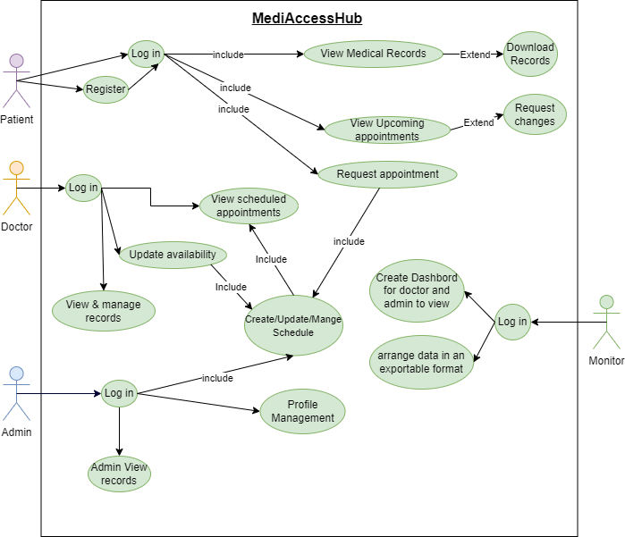

***Use Case Descriptipn***

***Use Case Description for Patient (Prateek)***

1. Registering a new user

|  |  |
| --- | --- |
| Use Case Name | Patient Registration and Login |
| Participating Actor | Patient (Prateek) |
| Goal | The goal of this Use case is to allow user to create an account and login securely to enter in the system |
| Flow of Events | 1. The user goes to MediAccessHub portal. 2. A form with the patient’s details is filled in and completed. 3. The system then checks for invalid data and after completion, a new account is created. 4. The user is then sent to login page where they can enter their credentials and log into the account. 5. The system verifies the input;  * If incorrect: asks user to retry. * If correct: allows user to the dashboard. |
| Entry Condition | * The patient is required to visit the portal. * The registration form is filled. |
| Exit Condition | * A new account has been created. * Patients can now successfully login. * If there are any errors, the user is alerted, and resubmission is required. |

2. View and download Medical Records

|  |  |
| --- | --- |
| Use Case Name | Access Medical records and download reports. |
| Participating Actor | Patient (Prateek) |
| Goal | The goal here is to allow users to access their medical records and optionally download the required data. |
| Flow of Events | 1. The user logs into the portal. 2. In dashboard, user clicks on “View Medical Record” 3. The system gets the required record from the database. 4. The records are then displayed in a tabular form. 5. Each row contains download button at the end 6. The user can download medical records as required. |
| Entry Condition | * The patient is successfully logged in. |
| Exit Condition | * The records are displayed properly. * Downloading is easily available. * Errors are reported for missing any files or access denial. |

3. Request and Modify Appointment

|  |  |
| --- | --- |
| Use Case Name | Request and Manage Appointment |
| Participating Actor | Patient (Prateek) |
| Goal | The goal of this use case is to allow the user to request, view and change appointments with doctor. |
| Flow of Events | 1. The user logs into the portal. 2. User clicks to “Appointment” page 3. Patient can select to “Request Appointment” or “Upcoming Appointment” 4. In “Request Appointment” page, user can select doctor, date and time then submit the form. 5. Then the system checks availability and stores the form as pending. 6. After confirming, it is displayed to the user as a Confirmed Appointment. 7. Patient can also select “Upcoming Appointment” 8. Here the system displays all Confirmed and Pending Confirmation. 9. User also has option to click on “Request change” 10. Here, the system processes the update and sends confirmation of new Appointment. |
| Entry Condition | * The login credentials are correct. * Appointment form is submitted. |
| Exit Condition | * Appointments are successfully created. * User receives confirmation. * Stop the process if any error occurs. |

|  |  |
| --- | --- |
| Category | Description |
| Use Case Name | View and Manage Records |
| Participating Actor | Doctor (Tashfiqul) |
| Goal | To allow a doctor to create, edit, and delete medical records for their assigned patients. |
| Flow of event | 1. The Doctor selects an assigned patient to view their medical history, and the System displays the records page. The Doctor then performs a management action: • Create: Fills and submits a new record form. The System validates and saves it. • Edit: Selects and modifies an existing record. The System validates and updates it. • Delete: Selects a record and confirms its removal. The System deletes it.. Finally, the System updates the display to reflect the successful action. |
| Entry Condition | - The Doctor must be successfully logged into the MediAccessHub system. - The Doctor must have selected an assigned patient whose records are to be managed. |
| Exit Condition | - If successful: A new medical record is created, an existing one is updated, or a record is deleted, with changes reflected in the patient's history. An audit log is recorded. - OR: An error message is displayed if the action fails. |
| Category | Description |
| Use Case Name | Update availability |
| Participating Actor | Doctor (Tashfiqul) |
| Goal | To allow a doctor to set and update their available hours for patient appointments. |
| Flow of event | 1. The Doctor navigates to the "My Availability" page. 2. The System displays a weekly calendar interface showing the Doctor's current schedule. 3. The Doctor selects a day or time block, then inputs their start and end times or marks the period as unavailable. 4. The Doctor clicks "Save" to submit the changes. 5. The System validates the new availability data (e.g., ensures start time is before end time). 6. The System saves the updated availability to the database.> 7. The System displays a confirmation message to the Doctor. |
| Entry Condition | The Doctor must be successfully logged into the MediAccessHub system. |
| Exit Condition | The Doctor's availability schedule is successfully updated in the database for the specified dates. The changes are available for the patient appointment system to use. If the update fails, an error message is displayed. |

|  |  |
| --- | --- |
| Category | Description |
| Use Case Name | Update availability |
| Participating Actor | Doctor (Tashfiqul) |
| Goal | To allow a doctor to set and update their available hours for patient appointments. |
| Flow of event | 1. The Doctor navigates to the "My Availability" page. 2. The System displays a weekly calendar interface showing the Doctor's current schedule. 3. The Doctor selects a day or time block, then inputs their start and end times or marks the period as unavailable. 4. The Doctor clicks "Save" to submit the changes. 5. The System validates the new availability data (e.g., ensures start time is before end time) 6. The System saves the updated availability to the database. 7. The System displays a confirmation message to the Doctor. |
| Entry Condition | The Doctor must be successfully logged into the MediAccessHub system. |
| Exit Condition | The Doctor's availability schedule is successfully updated in the database for the specified dates. The changes are available for the patient appointment system to use. If the update fails, an error message is displayed. |

|  |  |
| --- | --- |
| Category | Description |
| Use Case Name | View scheduled appointments |
| Participating Actor | Doctor (Tashfiqul) |
| Goal | To allow a doctor to view their upcoming confirmed appointments in an organized format, such as a calendar. |
| Flow of event | 1. The Doctor navigates to the "Appointments" or "My Schedule" page within the portal. 2. The System sends a request to the server to fetch the doctor's appointment data. 3. The server queries the database for all appointments linked to the logged-in doctor's ID. 4. The System displays the retrieved appointments in a weekly or monthly calendar view. 5. Each entry on the calendar clearly shows the patient's name and the appointment time. |
| Entry Condition | The Doctor must be successfully logged into the MediAccessHub system. |
| Exit Condition | The Doctor has successfully viewed their schedule of upcoming appointments. No data in the system is changed by this action. If the schedule cannot be loaded, an error message is displayed. |

**Use case descriptions for Admin (Saif)**

**Admin login**

|  |  |
| --- | --- |
| Use Case Name | Admin Login |
| Participating Actor | Admin (SAIF) |
| Goal | Login with secure credential to admin dashboard. |
| Flow of Events | 1. Admin visits the system Login 2. The system will display a login page requiring login credentials. 3. Admin will enter a valid username and password. 4. System verifies login information. 5. Admin is granted access to dashboard upon successful verification 6. Admin is granted access and dashboard is displayed. |
| Entry Condition | Admin access the portal through login page |
| Exit Condition | Admin successfully logs in after successful verification and dashboard is loaded. |

**Profile Management:**

|  |  |
| --- | --- |
| Use Case | Profile Management |
| Participating Actor | Admin (SAIF) |
| Goal | Manage user profile for both Doctor and Patient |
| Flow of Events | 1. Admin access list of all registered doctors and patient 2. Admin can view or edit doctor and patient profile 3. Admin will approve/reject doctor registration 4. Admin updates user information as needed 5. Admin can active/inactive user profile 6. Admin can terminate doctor profile upon resigning |
| Entry Condition | Admin logged into the dashboard. |
| Exit Condition | Updates made to user profiles are saved in the system database. |

**Schedule Management**

|  |  |
| --- | --- |
| Use Case | Create/update/manage Schedule |
| Participating Actor | Admin (SAIF) |
| Goal | Manage appointment table, doctor availability and approve any updates to the system |
| Flow of event | 1. Admin logs into the dashboard 2. Admin view updated Doctor availability and create schedule 3. Admin receives notifications of changes 4. Admin update timetable after an appointment is booked 5. Admin approve/reject doctor availability change mid-week 6. Admin approves/rejects any changes to appointments made by doctor or patient. 7. Admin reviews and take decision for any system update 8. System applies approved updates and reflects the changes 9. Notifications are sent to the users |
| Entry Condition | Admin is logged into the system and access create/update/manage schedule section |
| Exit Condition | All updates and changes are approved and applied and saved into the database |

**Admin View Record**

|  |  |
| --- | --- |
| Use Case | View Medical Records |
| Participating Actor | Admin (SAIF) |
| Goal | Access and view all medical records |
| Flow of Events | 1. Admin logs into the system 2. Admin views medical record section 3. Admin views patient medical history 4. Admin view appointment history and upcoming appointment 5. Admin views other records such as prescriptions, test results, etc. |
| Entry Condition | Admin is logged in and open view record dashboard |
| Exit Condition | Medical records are displayed for admin viewing only |

**Use case Description for Monitor (Arnob)**

|  |  |
| --- | --- |
| Use Case Name | Create dashboard for doctor and admin view |
| Participating Actor | Monitor (Arnob) |
| Flow of event | **1.** Monitor logs into the system.  2. System loads the recent log in history and appointment activity.  3. Monitor views the dashboard with login, appointments stats.  4. Option to filter by date or user role.  5. Data is updated real-time on the dashboard. |
| Entry Condition | Monitor logs into the system successfully. |
| Exit Condition | Dashboard is loaded and the stats are displayed clearly. Filters are applied when needed. |

|  |  |
| --- | --- |
| Use Case Name | Arrange data in an exportable format |
| Participating Actor | Monitor (Arnob) |
| Flow of event | **1.** Monitor selects a patient from the dashboard list.  2. Medical records for the selected patient can are collected from the database.  3. Monitor clicks Export and gets the option to choose from PDF or CSV.  4. Data is arranged and formatted.  5. Exported file is generated and downloaded. |
| Entry Condition | Patient list and recird are visible |
| Exit Condition | Exported file is downloaded successfully or try again if not successfull. |

**Sequence Diagram for MediAccessHub**

**Sequence Diagram for Patient(parteek)**

1. Registering a new patient/user

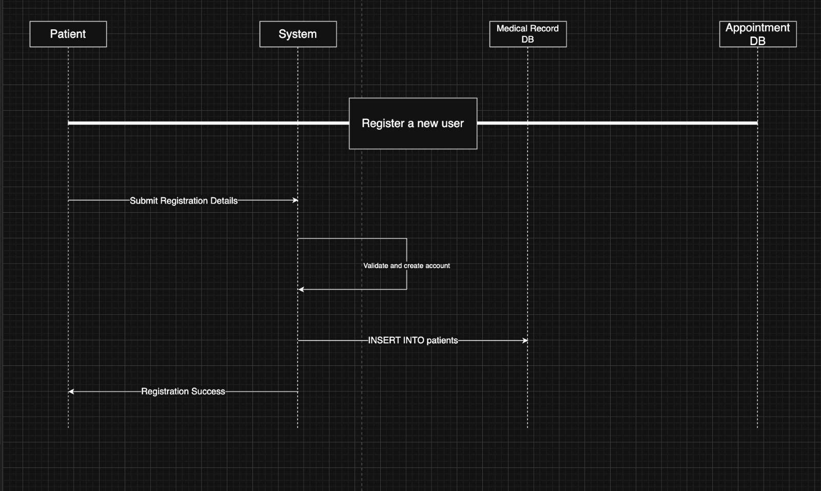

1. Viewing Medical records and downloading if required

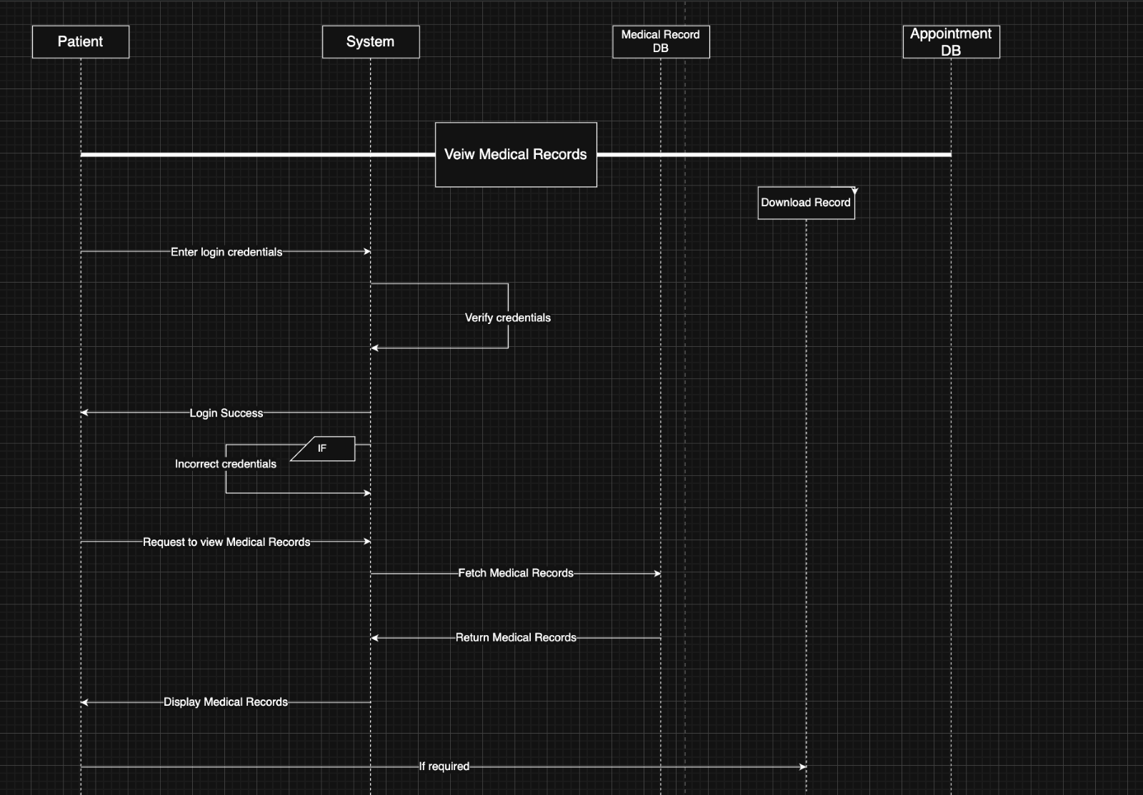

1. Making and viewing appointments

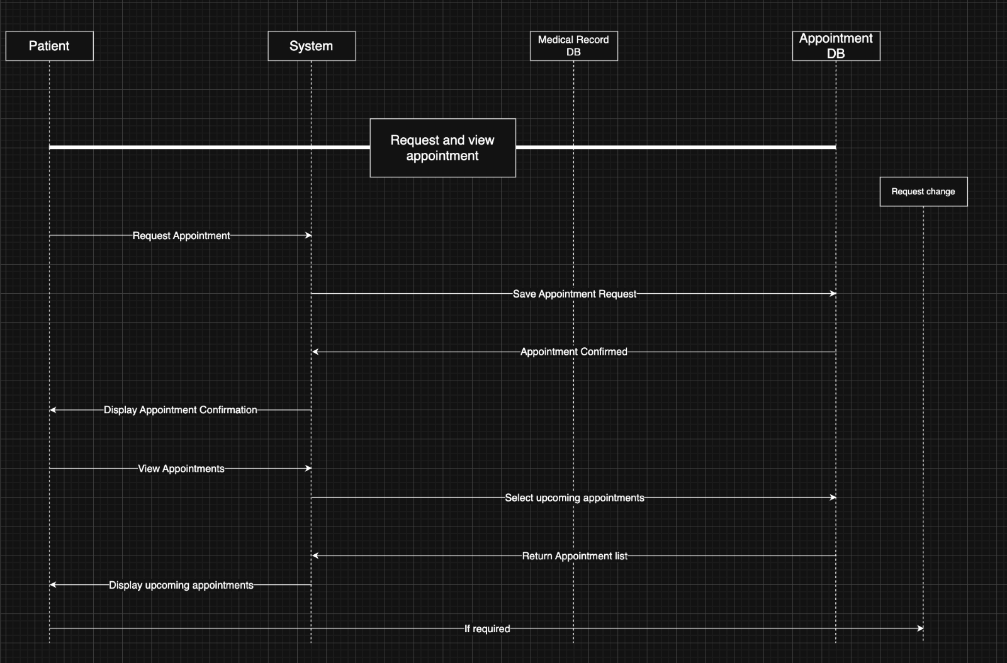

**Sequence Diagram for Doctor:**

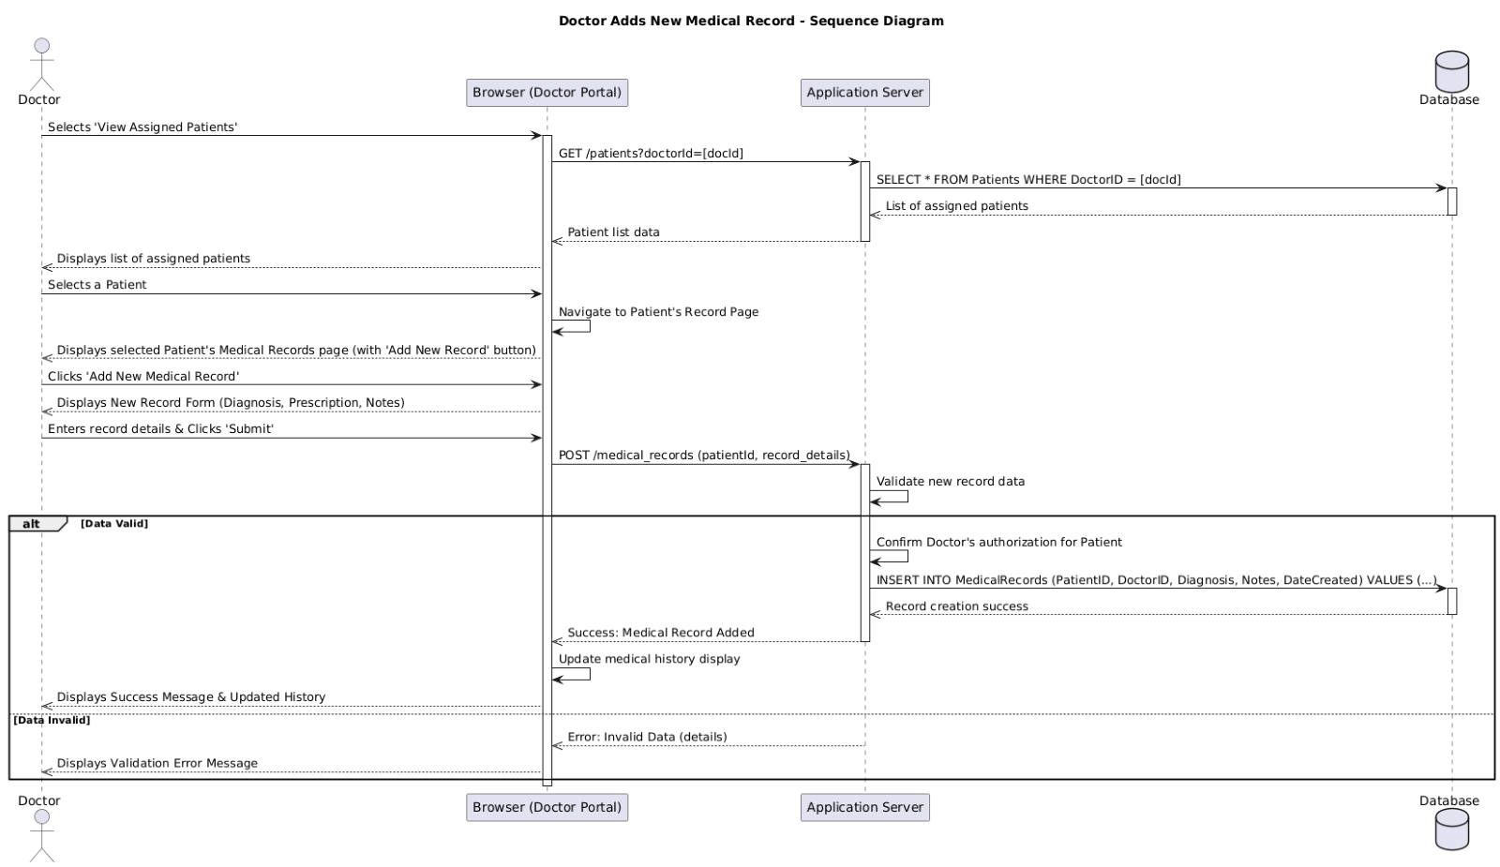

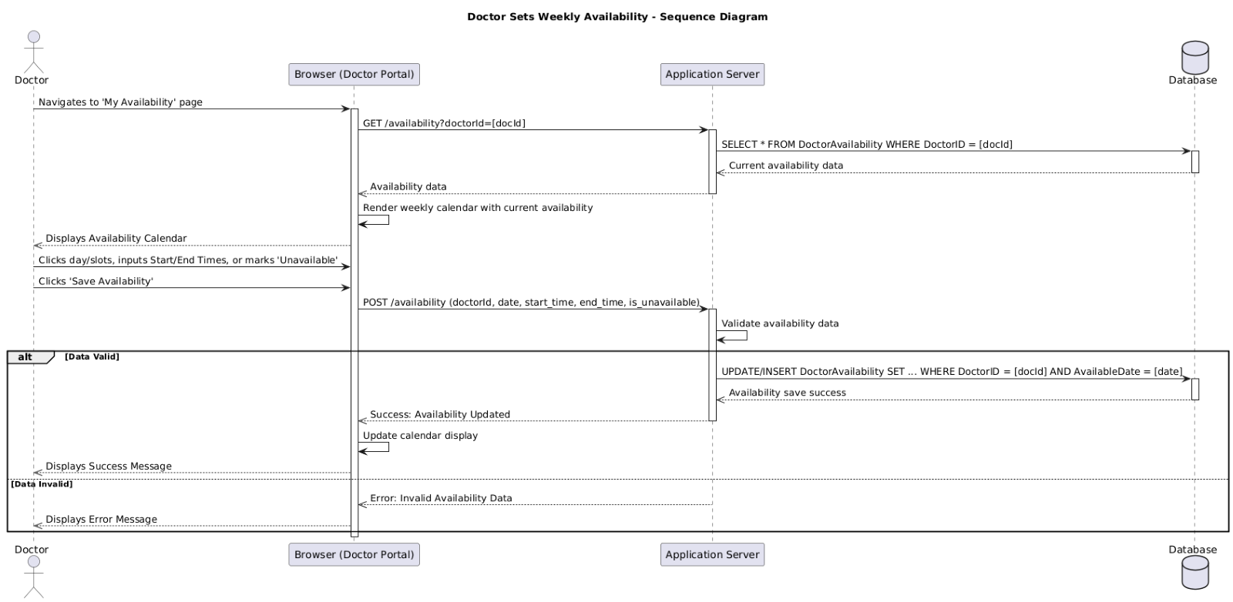

, Picture, Picture

**Sequence Diagram for Admin (Saif):**

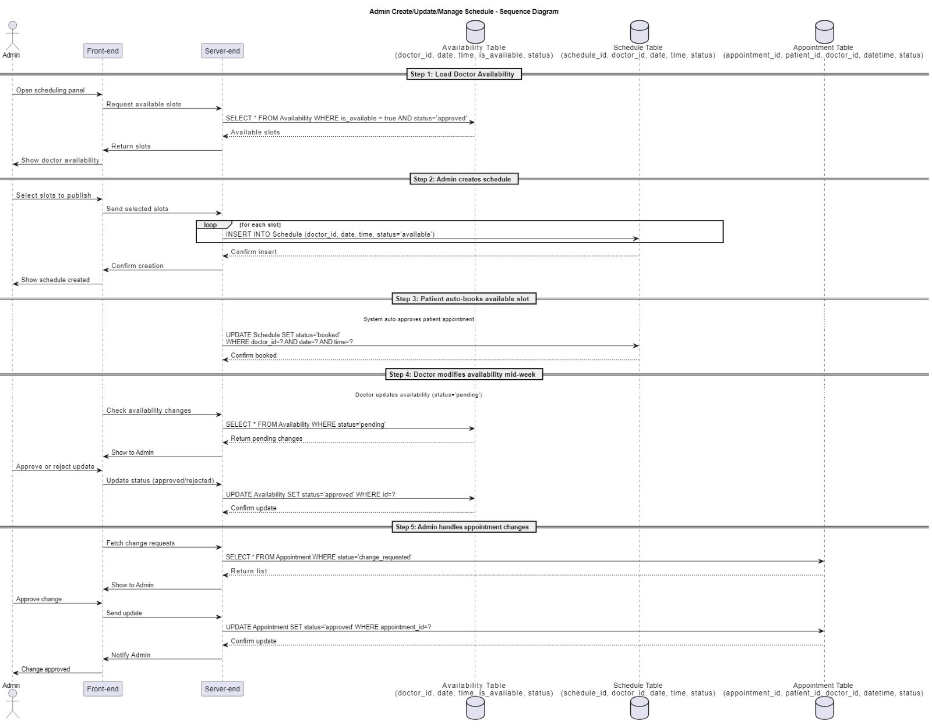  
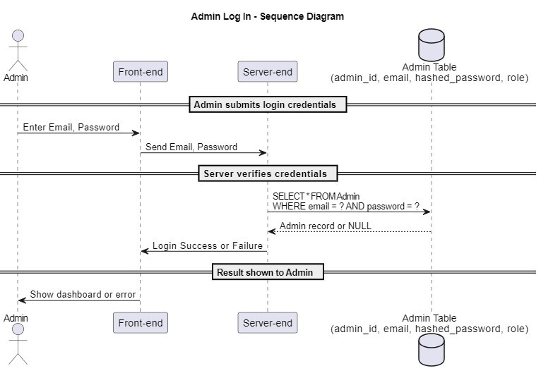  
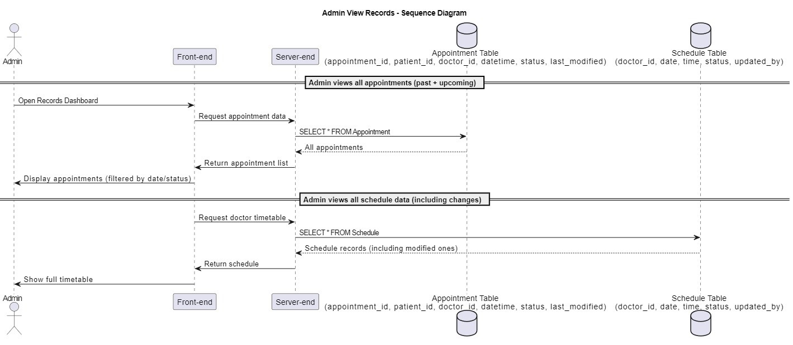  
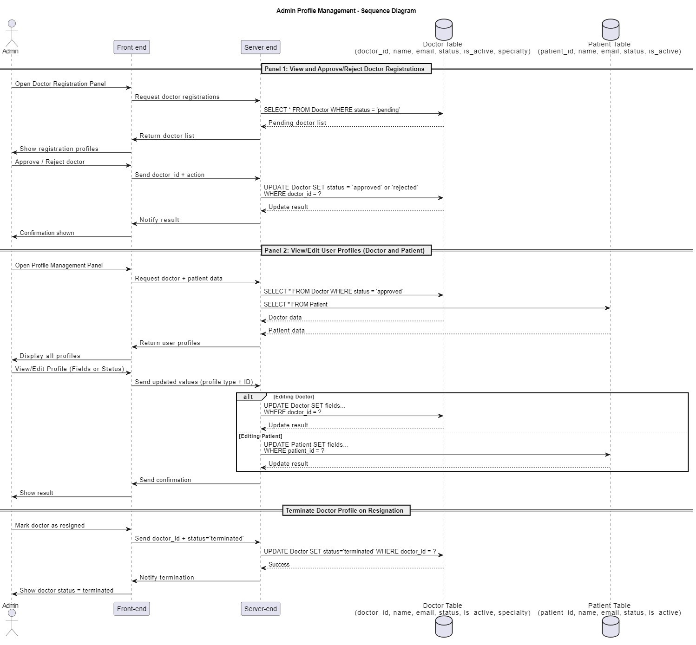

**Monitor sequence diagram(arnob):**

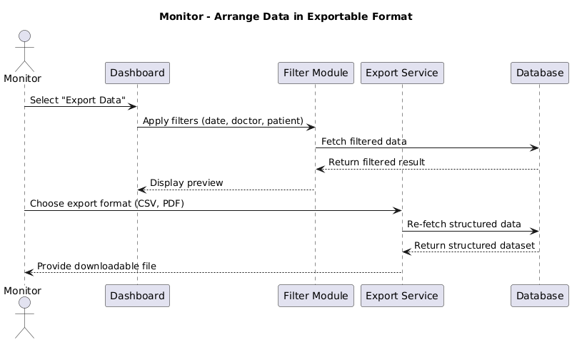

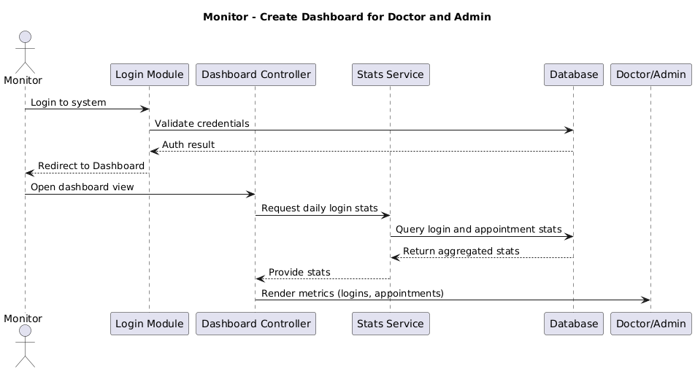

**Resource Management Document – MediAccessHub**

**1. Introduction(prateek)**

Resource Management ensures that all modules of MediAccessHub — including Doctor, Patient, Admin, and Monitoring components — are developed and maintained efficiently. It focuses on optimal use of human resources, technology, and time while ensuring each team member can contribute effectively toward their respective sections.

**2. Human Resources**

|  |  |  |
| --- | --- | --- |
| **Team Member** | **Role** | **Responsibility Summary** |
| Tashfiqul Rhidoy Prodhan | Doctor Portal Developer | Handles doctor login, dashboard, availability update, patient record operations |
| Md Mahmudul Hasan Saif | Admin Portal Developer | Develop admin interface, user management, schedule system and approval flows |
| Prateek Maharjan | Patient Portal Developer | Manages patient registration, appointments, record access, and interface usability. |
| Abyead Faisal Arnob | Monitoring & Reporting Developer | Implements dashboards, data tracking, visualization, and export functions. |

**3. Technical Resources (tashfiqul)**

|  |  |
| --- | --- |
| **Resource Type** | **Tools & Details** |
| Development Tools | Visual Studio Code, IntelliJ, or any IDE suitable for web & backend development |
| Version Control | GitHub – to track source code and enable collaborative development |
| Hosting/Test Server | Localhost or cloud environments like Heroku, Vercel, or Firebase (free tiers) |
| Database | MySQL / Firebase Realtime Database / MongoDB (based on selected backend) |
| Other Dependencies | Node.js / Express / Django (backend frameworks as required) |

**4. Financial Resources (Arnob)**

* **Estimated Cost:** $0
* **Remarks:** All components will utilize **open-source** or **freemium tools**. No paid resources are required unless upgraded features or deployments are later desired.

**5. Module-Wise Resource Assignment**

**Doctor Portal (Tashfiqul)**

* **Assigned Developer:** Tashfiqul Rhidoy Prodhan
* **Responsibilities:**
  + Build secure login system for doctors
  + Design and implement dashboards
  + Enable CRUD operations for patient records
  + Manage doctor availability using calendar interface
  + View scheduled appointments
* **Resources Used:**
  + PC/Laptop
  + Coding software (IDE)
  + Secure database with role-based access
  + GitHub for code tracking

**Patient Portal (Prateek)**

* **Assigned Developer:** Prateek Maharjan
* **Responsibilities:**
  + Enable user registration and secure login
  + Display medical records with download options
  + Implement appointment request and modification flows
* **Resources Used:**
  + HTML/CSS, React or Vue.js for frontend
  + Database for patient records and appointments
  + Secure encryption libraries for password hashing
  + Form validation logic

**Admin Portal (saif)**

* **Assigned Developer:** Md Mahmudul Hasan Saif
* **Responsibility:**
  + Manage all users (Doctors and patients)
  + Approve/Reject doctor registration and availability
  + Manage system schedule and appointment conflicts
  + Maintain system-Wide access control and monitoring
* **Resources Used:**
  + Admin dashbaord framework ( e.g, AdminLTE, Bootstrap)
  + Role-based access control mechanisms
  + Notifications module for approvals
  + Audit trail loggin system

**Monitoring & Reports Module (Arnob)**

* **Assigned Developer:** Abyead Faisal Arnob
* **Responsibilities:**
  + Implement dashboards showing login and appointment statistics
  + Export data in CSV or PDF
  + Real-time system usage tracking
* **Resources Used:**
  + Charting libraries (e.g., Chart.js, D3.js)
  + Export libraries (e.g., jsPDF, PapaParse)
  + File generation tools
  + Backend query optimization for reporting

**6. Risk Management and Contingencies (Saif)**

* **Data Loss**: GitHub version control and local backups mitigate this
* **Team Unavailability**: Team members can hand over documentation/code access
* **Performance Bottlenecks**: Load testing to be done during development to avoid crashes
* **Security Threats**: Secure password hashing, role-based access and HTTPS enforcement

**Pseudocode for MediAccessHub**

**Pseudocode for Patient (Prateek):**

1. Register a new user

START RegisterNewUser

DISPLAY "Enter Full Name, Email, Password, Confirm Password"

INPUT fullName, email, password, confirmPassword

IF password == confirmPassword THEN

CALL ValidateInput(fullName, email, password)

IF input is valid THEN

HASH password

INSERT newUser INTO PatientDatabase

DISPLAY "Registration Successful"

ELSE

DISPLAY "Invalid Input. Please check your details."

ENDIF

ELSE

DISPLAY "Passwords do not match."

ENDIF

END RegisterNewUser

1. Login

START PatientLogin

DISPLAY "Enter Email and Password"

INPUT email, password

WHILE loginAttempts < 3 DO

IF CredentialsAreValid(email, password) THEN

DISPLAY "Login Successful"

BREAK

ELSE

DISPLAY "Invalid credentials. Try again."

loginAttempts = loginAttempts + 1

ENDIF

ENDWHILE

IF loginAttempts == 3 THEN

DISPLAY "Too many attempts. Try again later."

ENDIF

END PatientLogin

1. View Medical Record

START ViewMedicalRecords

IF userIsAuthenticated THEN

FETCH medicalRecords FROM MedicalRecordDatabase WHERE patientEmail = user.email

DISPLAY records in table format

DISPLAY "Download" button for each record

ELSE

DISPLAY "Access Denied. Please login first."

ENDIF

END ViewMedicalRecords

1. Request appointment

START RequestAppointment

DISPLAY "Select doctor and preferred time slot"

INPUT doctorName, appointmentDate, appointmentTime

IF selectedSlot IS available THEN

SAVE appointment TO AppointmentDatabase

DISPLAY "Appointment Confirmed"

ELSE

DISPLAY "Selected slot is not available. Please choose a different time."

ENDIF

END RequestAppointment

1. View Upcoming Appointments & Request Change

START ViewAppointments

FETCH appointments FROM AppointmentDatabase WHERE patientEmail = user.email

DISPLAY list of upcoming appointments

IF patient selects "Request Change" THEN

DISPLAY form to select new date/time

INPUT newDate, newTime

IF new slot IS available THEN

UPDATE appointment WITH newDate, newTime

DISPLAY "Appointment Updated Successfully"

ELSE

DISPLAY "New slot unavailable"

ENDIF

ENDIF

END ViewAppointments

**Pseudocode: Doctor Portal**

**1. Doctor Login**

This pseudocode describes the logic for securely logging in a doctor.

FUNCTION doctorLogin(email, password)

// Find the user in the database with the provided email

user = Database.findUserByEmail(email)

// Check if a user with that email was found

IF user IS NOT found THEN

RETURN "Error: No account found with that email."

END IF

// Verify the user's role is 'Doctor'

IF user.role IS NOT "Doctor" THEN

RETURN "Error: Access denied for this role."

END IF

// Hash the input password and compare it to the stored hash

IF password_matches(user.hashedPassword, password) THEN

// If successful, create a secure session

Session.create(user.id)

RETURN "Login successful"

ELSE

// If passwords do not match, return an error

RETURN "Error: Invalid password."

END IF

END FUNCTION

**2. Display Doctor Dashboard**

This logic fetches the necessary data to show the doctor's personalized dashboard.

FUNCTION getDashboardData(loggedInDoctorID)

// Get today's date to find current appointments

currentDate = today()

// Get all appointments for the logged-in doctor scheduled for today

todaysAppointments = Database.query("SELECT * FROM Appointments WHERE DoctorID = loggedInDoctorID AND AppointmentDate = currentDate")

// Get the doctor's name for a welcome message

doctorInfo = Database.query("SELECT FullName FROM Users WHERE UserID = loggedInDoctorID")

welcomeMessage = "Welcome, " + doctorInfo.FullName

// Return all data needed to build the dashboard

RETURN { welcomeMessage, todaysAppointments }

END FUNCTION

**3. View Assigned Patients**

This logic retrieves the list of all patients assigned to the logged-in doctor.

FUNCTION viewAssignedPatients(loggedInDoctorID)

// Query the database for all patients linked to this doctor's ID

assignedPatientsList = Database.query("SELECT PatientID, FullName, DateOfBirth FROM Patients WHERE DoctorID = loggedInDoctorID")

// Return the list

RETURN assignedPatientsList

END FUNCTION

**4. Manage Medical Records**

This is a complex functionality broken into smaller parts: Create, Edit, and Delete.

**Create Medical Record**

FUNCTION createMedicalRecord(loggedInDoctorID, patientID, recordData)

// First, confirm this doctor is authorized for this patient

isAuthorized = Database.verifyDoctorPatientLink(loggedInDoctorID, patientID)

IF isAuthorized IS FALSE THEN

RETURN "Error: Not authorized for this patient."

END IF

// Validate the incoming data (e.g., check for empty fields)

isValid = validate(recordData)

IF isValid IS FALSE THEN

RETURN "Error: Invalid data provided."

END IF

// Save the new record to the database

Database.query("INSERT INTO MedicalRecords (PatientID, DoctorID, Diagnosis, Prescription, Notes) VALUES (...)")

RETURN "Success: Medical record created."

END FUNCTION

**Edit Medical Record**

FUNCTION editMedicalRecord(loggedInDoctorID, patientID, recordID, updatedData)

// Confirm this doctor is authorized for this patient

isAuthorized = Database.verifyDoctorPatientLink(loggedInDoctorID, patientID)

IF isAuthorized IS FALSE THEN

RETURN "Error: Not authorized for this patient."

END IF

// Validate the updated data

isValid = validate(updatedData)

IF isValid IS FALSE THEN

RETURN "Error: Invalid data provided."

END IF

// Update the specific record in the database

Database.query("UPDATE MedicalRecords SET ... WHERE RecordID = recordID")

RETURN "Success: Medical record updated."

END FUNCTION

**Delete Medical Record**

FUNCTION deleteMedicalRecord(loggedInDoctorID, patientID, recordID)

// Confirm this doctor is authorized for this patient

isAuthorized = Database.verifyDoctorPatientLink(loggedInDoctorID, patientID)

IF isAuthorized IS FALSE THEN

RETURN "Error: Not authorized for this patient."

END IF

// Delete the specific record from the database

Database.query("DELETE FROM MedicalRecords WHERE RecordID = recordID")

RETURN "Success: Medical record deleted."

END FUNCTION

**5. Manage Availability**

This logic allows a doctor to set or update their work hours.

FUNCTION manageAvailability(loggedInDoctorID, availabilityData)

// availabilityData is a list of dates/times, e.g., [{date: "2025-07-10", start: "09:00", end: "17:00"}]

// Loop through each availability entry provided by the doctor

FOR EACH entry IN availabilityData

// Validate the entry's data

IF entry.start_time IS AFTER entry.end_time THEN

CONTINUE to next entry with error message "Start time must be before end time"

END IF

// Check if an entry for this date already exists for the doctor

existingEntry = Database.query("SELECT * FROM DoctorAvailability WHERE DoctorID = loggedInDoctorID AND AvailableDate = entry.date")

IF existingEntry IS found THEN

// If it exists, update it with the new times

Database.query("UPDATE DoctorAvailability SET StartTime = entry.start, EndTime = entry.end WHERE ...")

ELSE

// If it doesn't exist, insert a new availability entry

Database.query("INSERT INTO DoctorAvailability (DoctorID, AvailableDate, StartTime, EndTime) VALUES (...)")

END IF

END FOR

RETURN "Success: Availability has been updated."

END FUNCTION

**Pseudocode for Admin (Saif):**

**Admin Login**

**Front-End (login page)**

Function adminLogin() {

username = input_username

password = input_password

send_login_info_to_server(username, password)

}

**Back-End (Server)**

Function send_login_info_to_server(username, password){

If check_credentials(username, password) == true {

Load_dashboard()

} else {

show_error(“Invalid username or password”)

}

}

**Profile Management**

**Front-End (profile Management Page)**

Function manageUserProfile() {

Admin_login_dashboard()

User_list = Fetch_all_users() // doctors and patients

Display_user_list(user_list)

Selected_user = Admin_selects_user()

User_profile = Fetch_user_profile(selected_user)

Display_user_profile(user_profile)

If admin_clicks_edit_profile() {

Update_data = Get_update_profile_input()

send_update_profile_to_server(update_data)

}

If admin_reviews_new_doctor_registration() {

registration_info = View_doctor_application()

Decision = Admin_approve_or_rejected(registration_info)

Send_registration_decision_to_server(registration_info, decision)

}

If admin_toggles_active_status() {

Status = Admin_select_active_or_Inactive()

Send_status_update_to_server(selected_user, status)

}

If admin_click_terminate_doctor() AND

Doctord_has_resigned(selected_user) {

Send_termination_request_to_server(selected_user)

}

}

**Back-End (server):**

Function Fetch_all_users() {

Return Query_all_registration_users() }

Function Fetch_user_profile(user_id) {

Return Query_user_profile_by_id(user_id) }

Function Send_update_profile_to_server(updated_data) {

If validate_profile_data(update_data) == true {

Update_profile_in_database(updated_data) } else {

Show_error (“Invalid profile data”)}}

Function Send_registration_decision_to_server(registration_info, decision) {

If decision == “approve” {

Approve_doctor_registration(registration_info)

Notify_doctor(“Registration Approved”) } else

Reject_doctor_registration(registration_info)

Notify_doctor(“Registration Rejected”) }}

Function Send_status_update_to_server(user_id, status) {

Update_user_status(user_id, status) // active or inactive

Notify_user_status_change(user_id, status) }

Function Send_termination_request_to_server(doctor_id) {

Doctor_has_resigned(doctor_id) == true {

Mark_doctor_as_terminated(doctor_id)

Notify_termination(doctor_id) } else {

Show error(“Doctor not eligible for termination”) }

}

**Create/Update/Manage schedule:**

**Front-End (schedule Management Page)**

Function manageSchedule() {

Admin_login_dashboard()

Doctor_availability = Fetch_update_availability()

Display_availability(doctor_availabiltiy)

if admin_wants_to_create_schedule() {

Schedule_input = Get_schedule_input()

Send_schedule_to_server(schedule_input)

}

If admin_recived_notification(“availability_change”) {

Change_details = View_change_request()

decison = Admin_approve_or_reject(change_details)

Send_availability_decision_to_server(change_details, decision)

}

If admin_recieve_notfication(“appointment_change”) {

Appointment_request = view_appointment_change()

decision = Admin_approve_or_reject(appointment_request)

Send_appointment_decision_to_server(appointment_request, decision) }

}

**Back-End (Server):**

Function send_schedule_to_server(shcedule_input) {

If validate_schedule(schedule_input) == true {

Save_schedule_to_database(schedule_input)

Notify_doctor(schedule_input) } else {

Log_error(“Invalid Schedule data”) }

}

Function send_availability_decison_to_server(change_details, decision) {

If decision == “approve” {

Apply_availability_update(change_details)

Notify_doctor_and_update_UI(change_details)

} else {

Reject_availabiltiy_update(change_details)

Notfiy_doctor_rejection(change_details)

} }

Function send_appointment_decision_to_server(appointment_change_request, decision) {

If decision == “approve”

Update_appointment_in_database(appointment_change_reqeust)

Notify_pateint_and_doctor(appointment-change_reqeust) }

}

**View Medical Records**

**Front-End (Admin Records Page)**

Function viewmedicalRecords() {

Admin_login_dahsboard()

Patient_id = Get_input(“Enter patient ID”)

Send_patient_id_to_server(server_ID)

}

**Back-End(server)**

Function send_patient_id_to_server(patient_id)

Id patient_exists(patient_id) == true {

Medical_history = Fetch_medical_history(patient_id)

Past_appointment = Fetch_pastappointment(patient_id)

Upcoming_appointments = Fetch_upcoming_appointment(patient_id)

Display_to_admin(medical_history, past_appoitnment, upcoming_appointments){

Else {

Show_error(“patient not found”) }

}

**Pseudocode for monitor (Arnob):**

**Front-end:**

1. Load Page and Display Patients List:

IF user_role IS Admin OR Doctor THEN

DISPLAY patient list table

ENABLE search and filter options

ELSE IF user_role IS Patient THEN

DISPLAY "Export My Records" button

1. Select Patient to View Records:

WHEN user clicks "Select" on a patient row THEN SET selected_patient_id = chosen ID

CALL API: GET /patients/{selected_patient_id}/records  
  
IF response.status IS success THEN  
 DISPLAY second table with medical records  
  
ELSE  
 DISPLAY "Access Denied" or "No Records Found"

1. Export the Record:

WHEN user clicks "Export as PDF" OR "Export as CSV" THEN SET export_format = selected option SET patient_id = selected_patient_id

CALL API: POST /export WITH patient_id AND export_format  
  
IF response.status IS success THEN  
 DOWNLOAD the returned file  
  
ELSE  
 DISPLAY "You are not authorized to export this data."

**Back End:**

1. Fetch Patient List:

FUNCTION get_patient_list(user_role, user_id): IF user_role IS Admin THEN RETURN all patients

ELSE IF user_role IS Doctor THEN  
 RETURN patients assigned to user_id  
  
ELSE IF user_role IS Patient THEN  
 RETURN only the record for user_id  
  
ELSE  
 RETURN "Access Denied"

1. Fetch Patient Medical Records:

FUNCTION get_patient_records(requesting_user_role, requesting_user_id, target_patient_id): IF requesting_user_role IS Admin THEN ALLOW access

ELSE IF requesting_user_role IS Doctor THEN  
 CHECK IF doctor is assigned to target_patient_id  
 IF NOT assigned THEN  
 RETURN "Access Denied"  
  
ELSE IF requesting_user_role IS Patient THEN  
 IF requesting_user_id != target_patient_id THEN  
 RETURN "Access Denied"  
  
FETCH and RETURN records from database

1. Export Record as File:

FUNCTION export_patient_record(user_role, user_id, patient_id, format): CALL get_patient_records(user_role, user_id, patient_id)

IF response IS "Access Denied" THEN  
 RETURN "Unauthorized"  
  
IF format IS PDF THEN  
 GENERATE PDF with patient record  
  
ELSE IF format IS CSV THEN  
 GENERATE CSV with patient record  
  
RETURN file for download

**UI Design for MediAccessHub**

**UI design for patient portal (Prateek):**

1. **The Access Portal**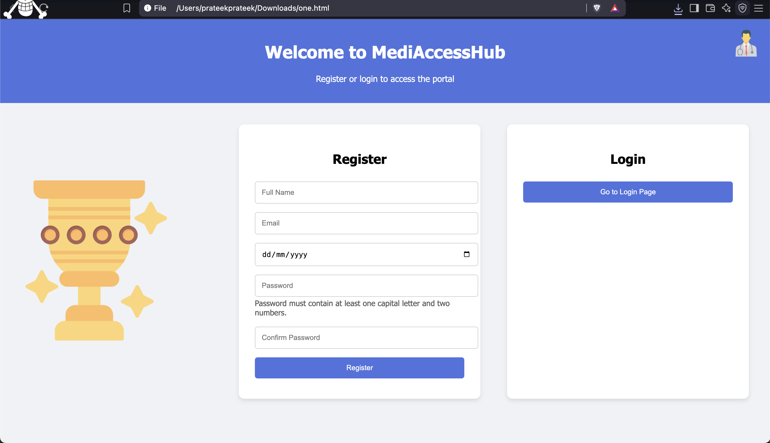
2. **Dashboard**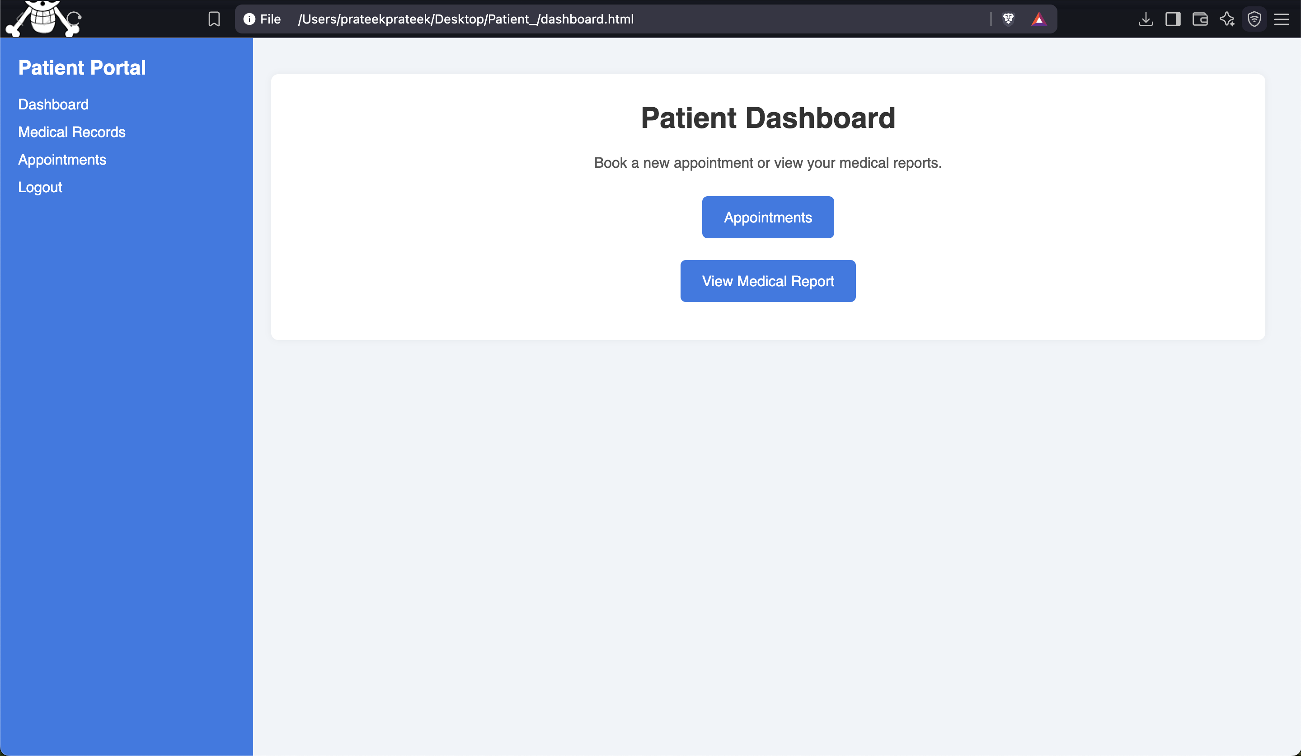
3. **Appointment Portal**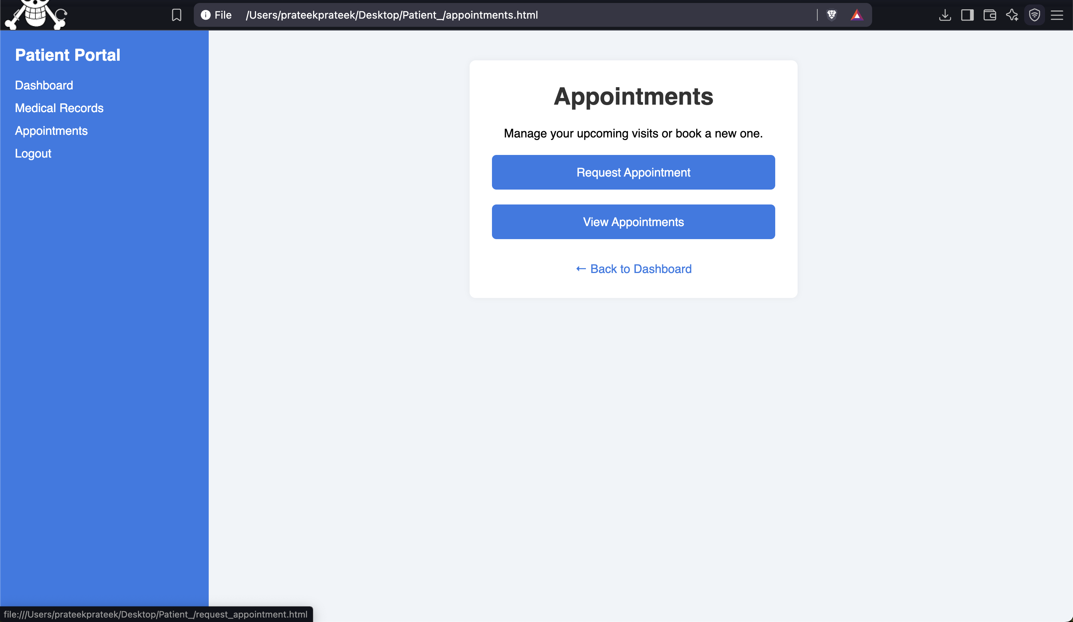

* **Request Appointment**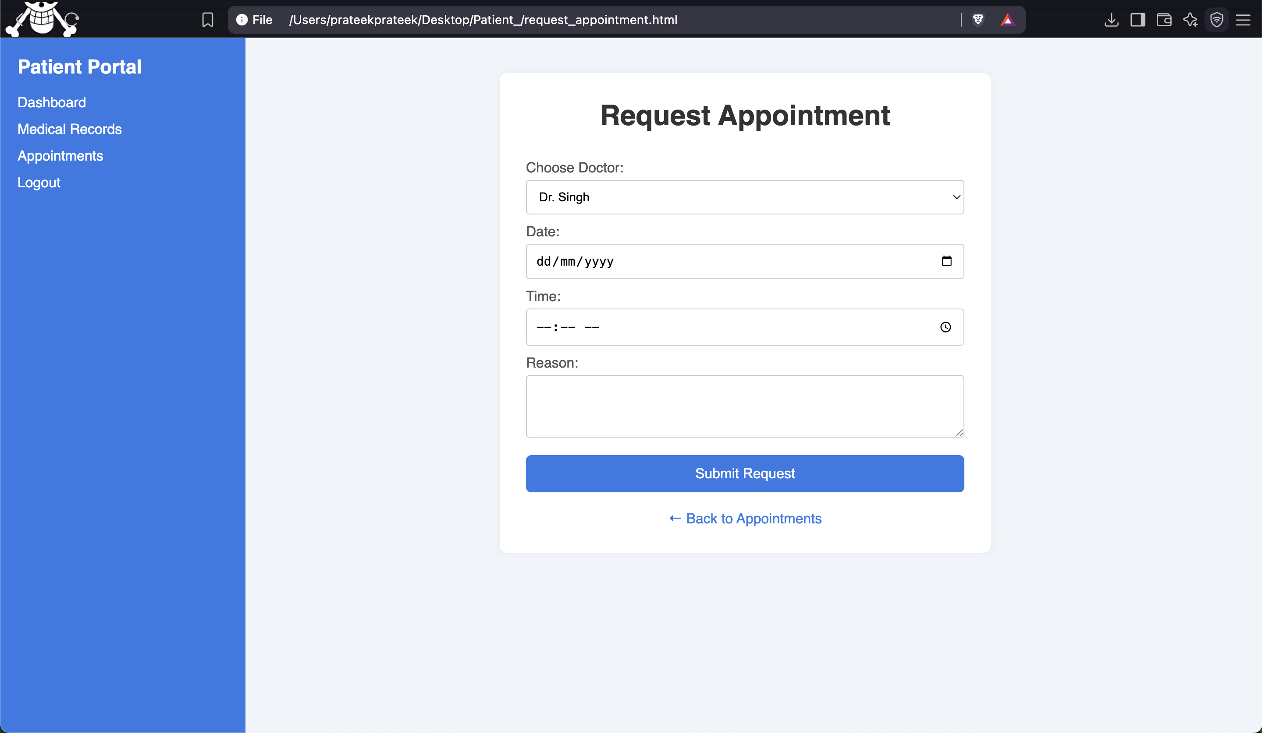
* **View Appointment**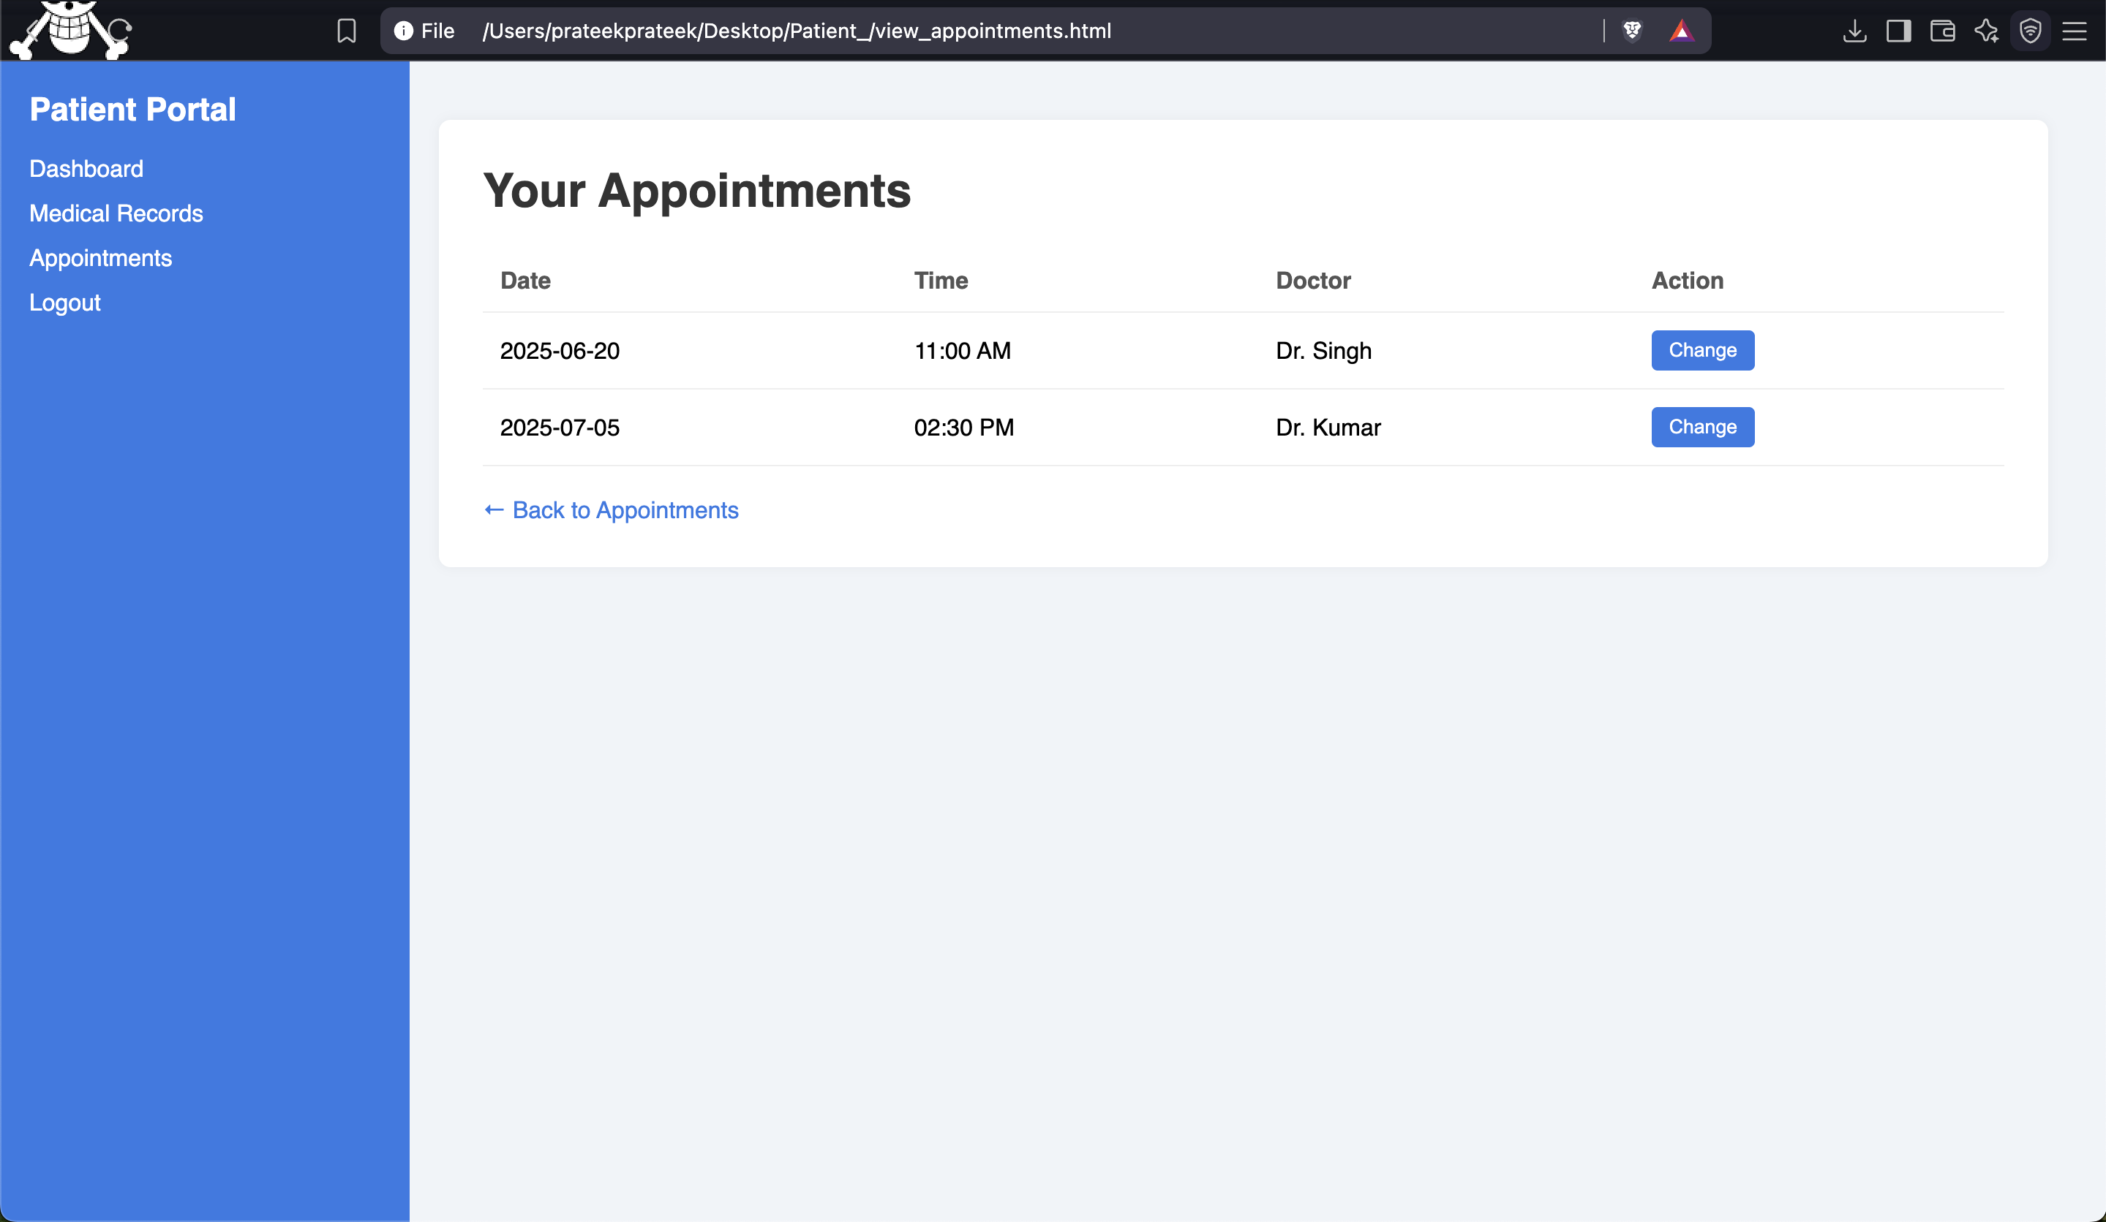

1. **View Medical Report**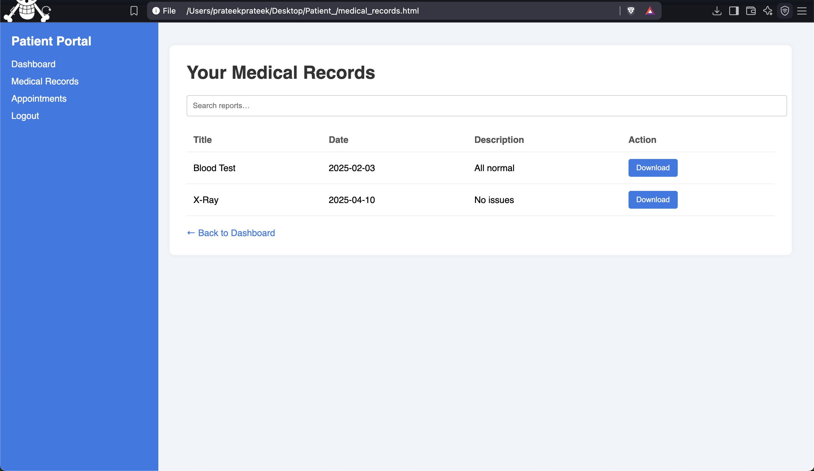

**UI design for Doctor’s Portal (Tashfiqul):**

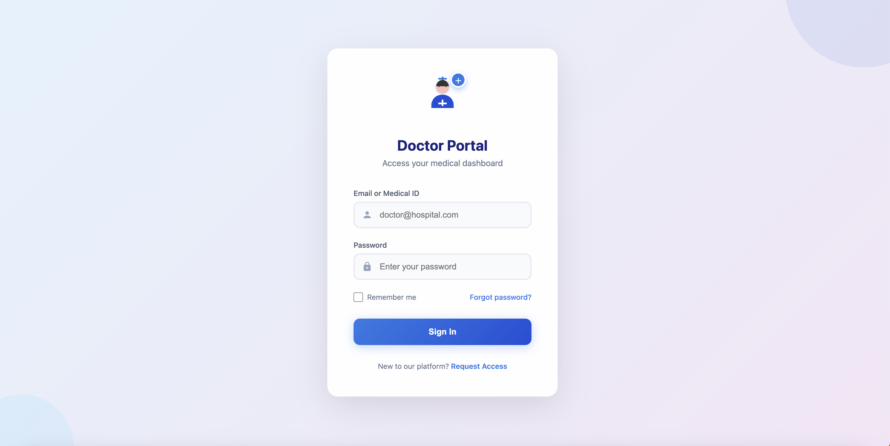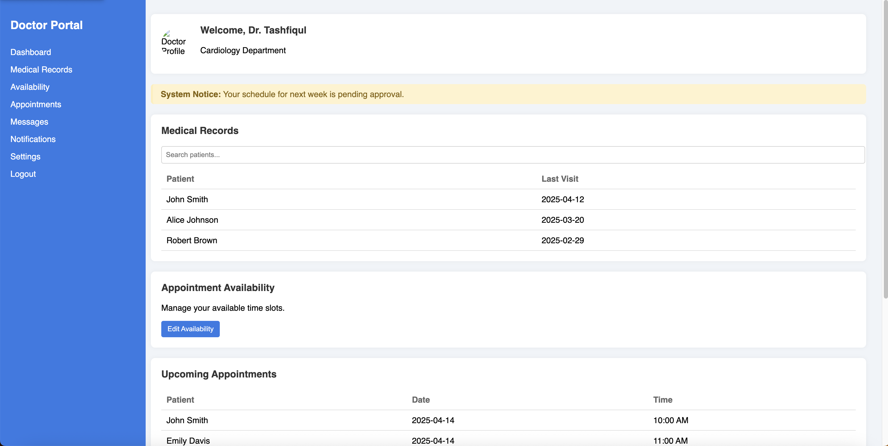

**Ui Design for MediAccessHub Admin Portal (Saif):**

**Admin Login:**

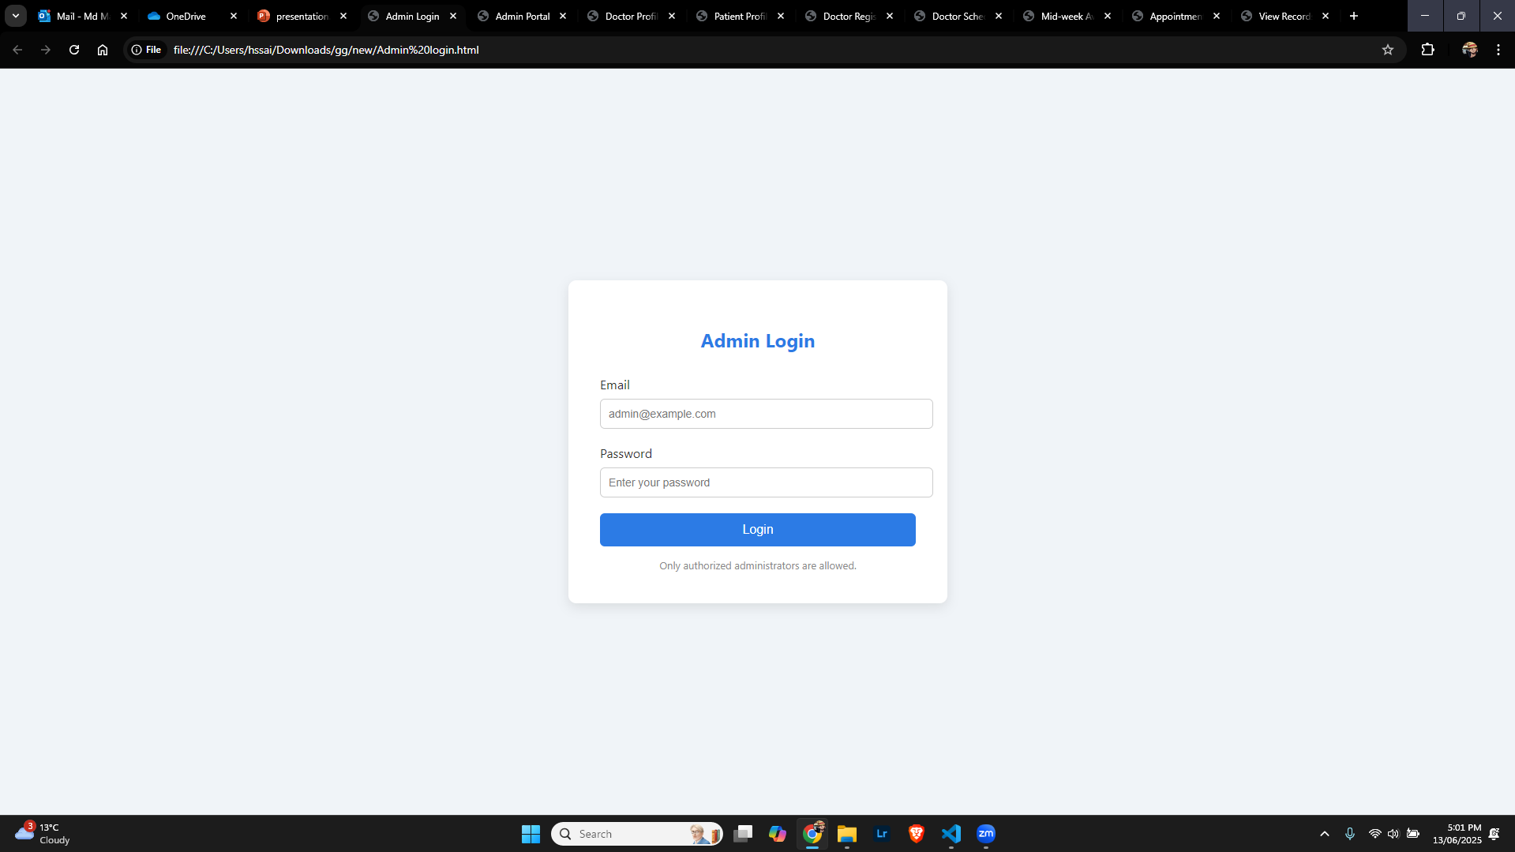Admin Dashboard:

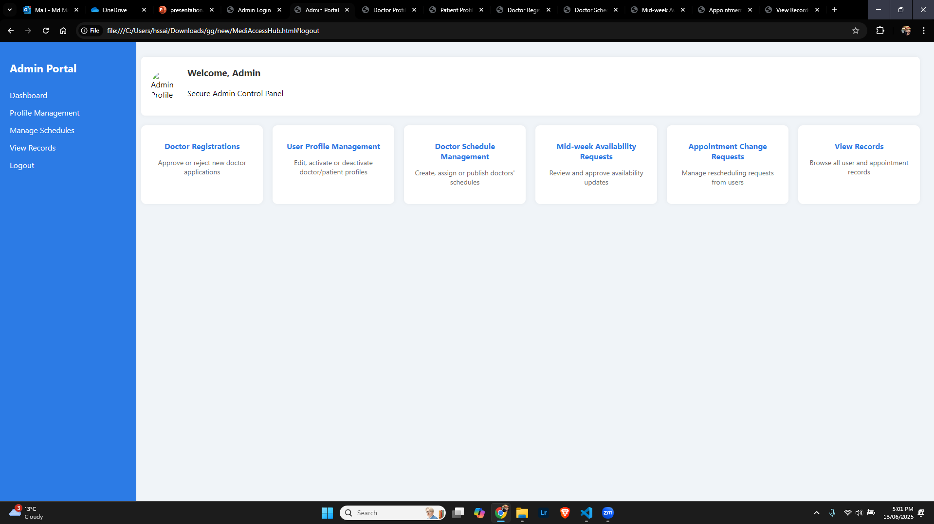

Admin Profile Management:

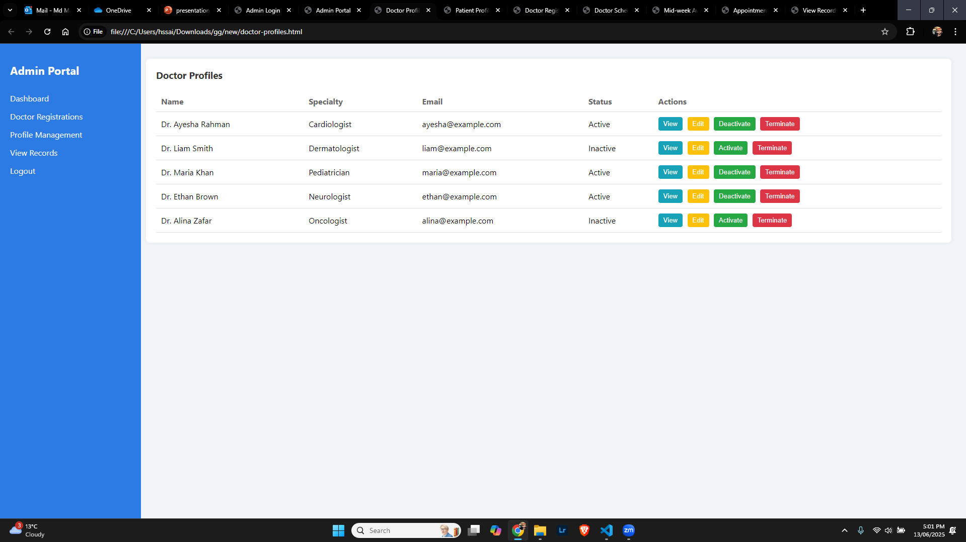

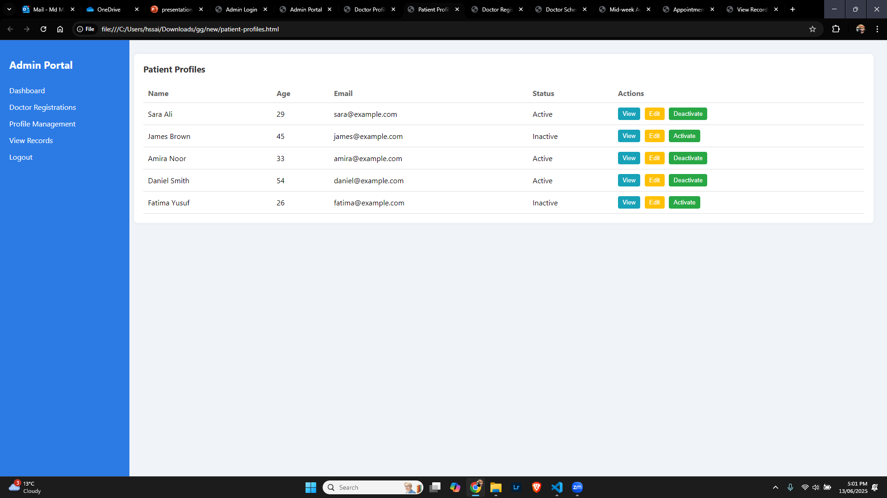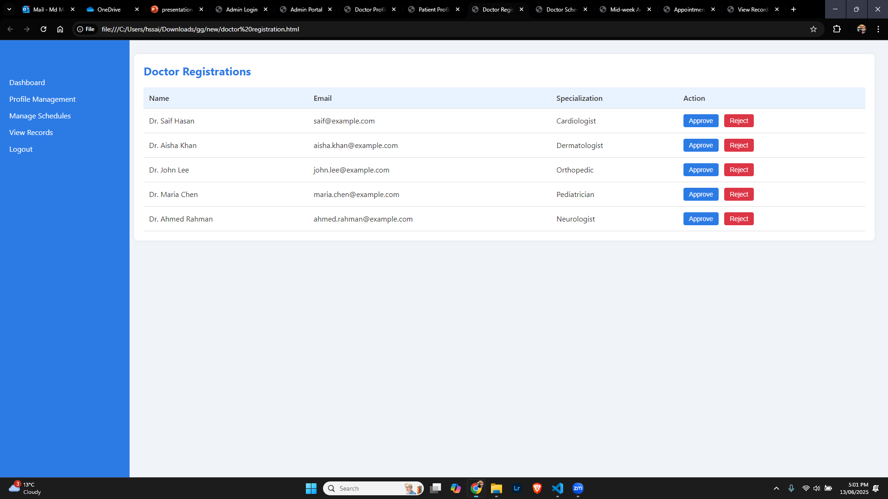

Create/Update/Manage Schedule:

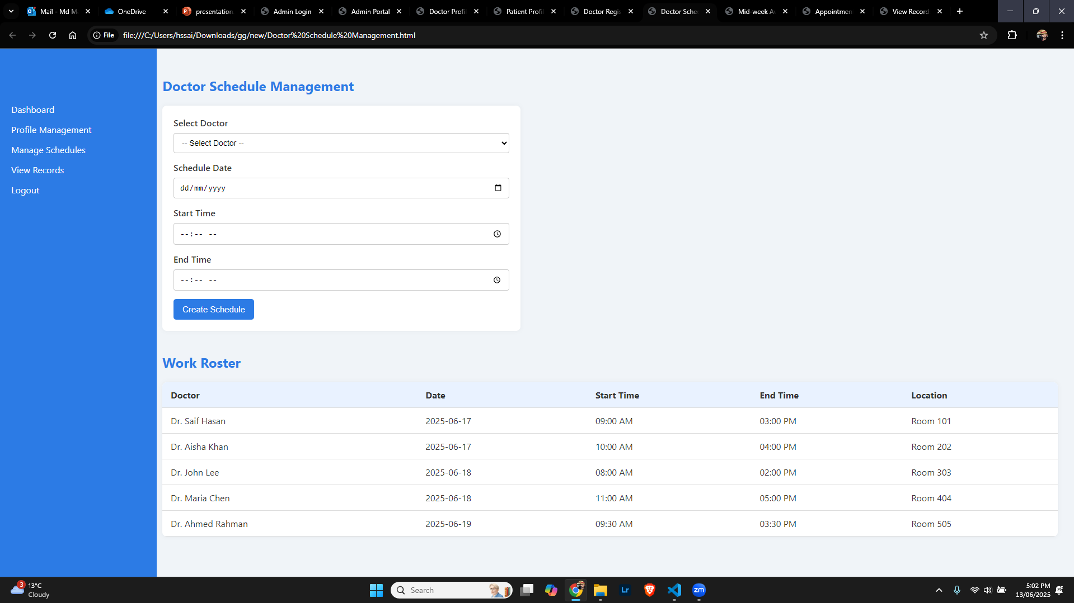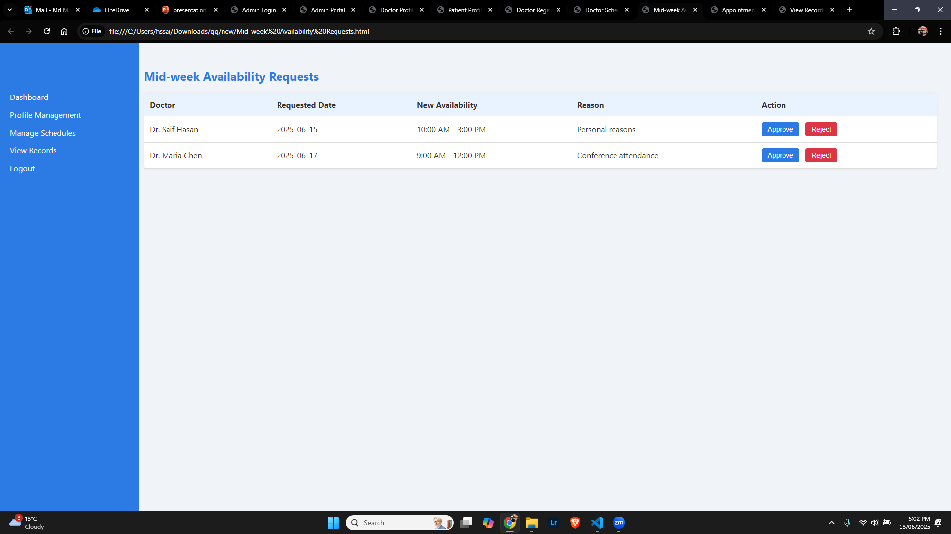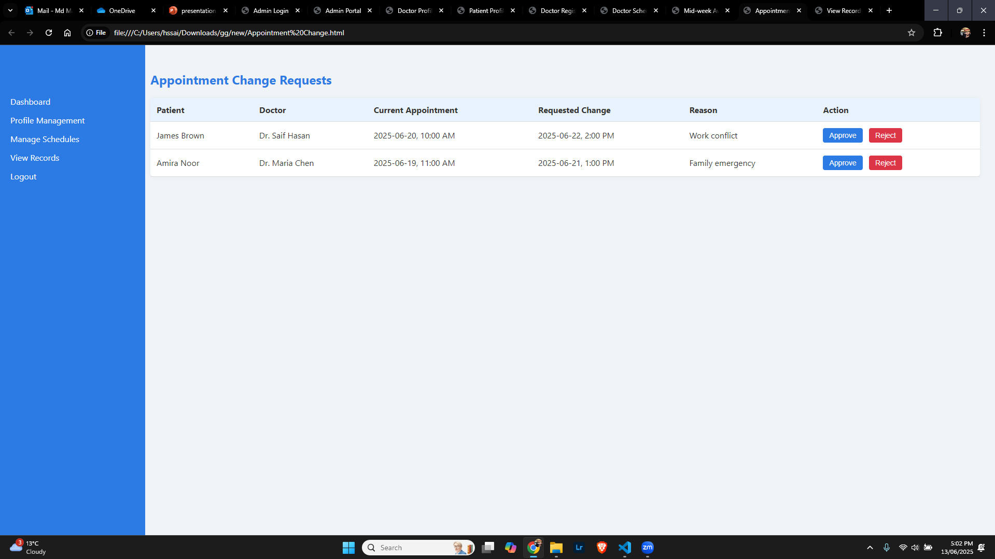

Admin View Record:

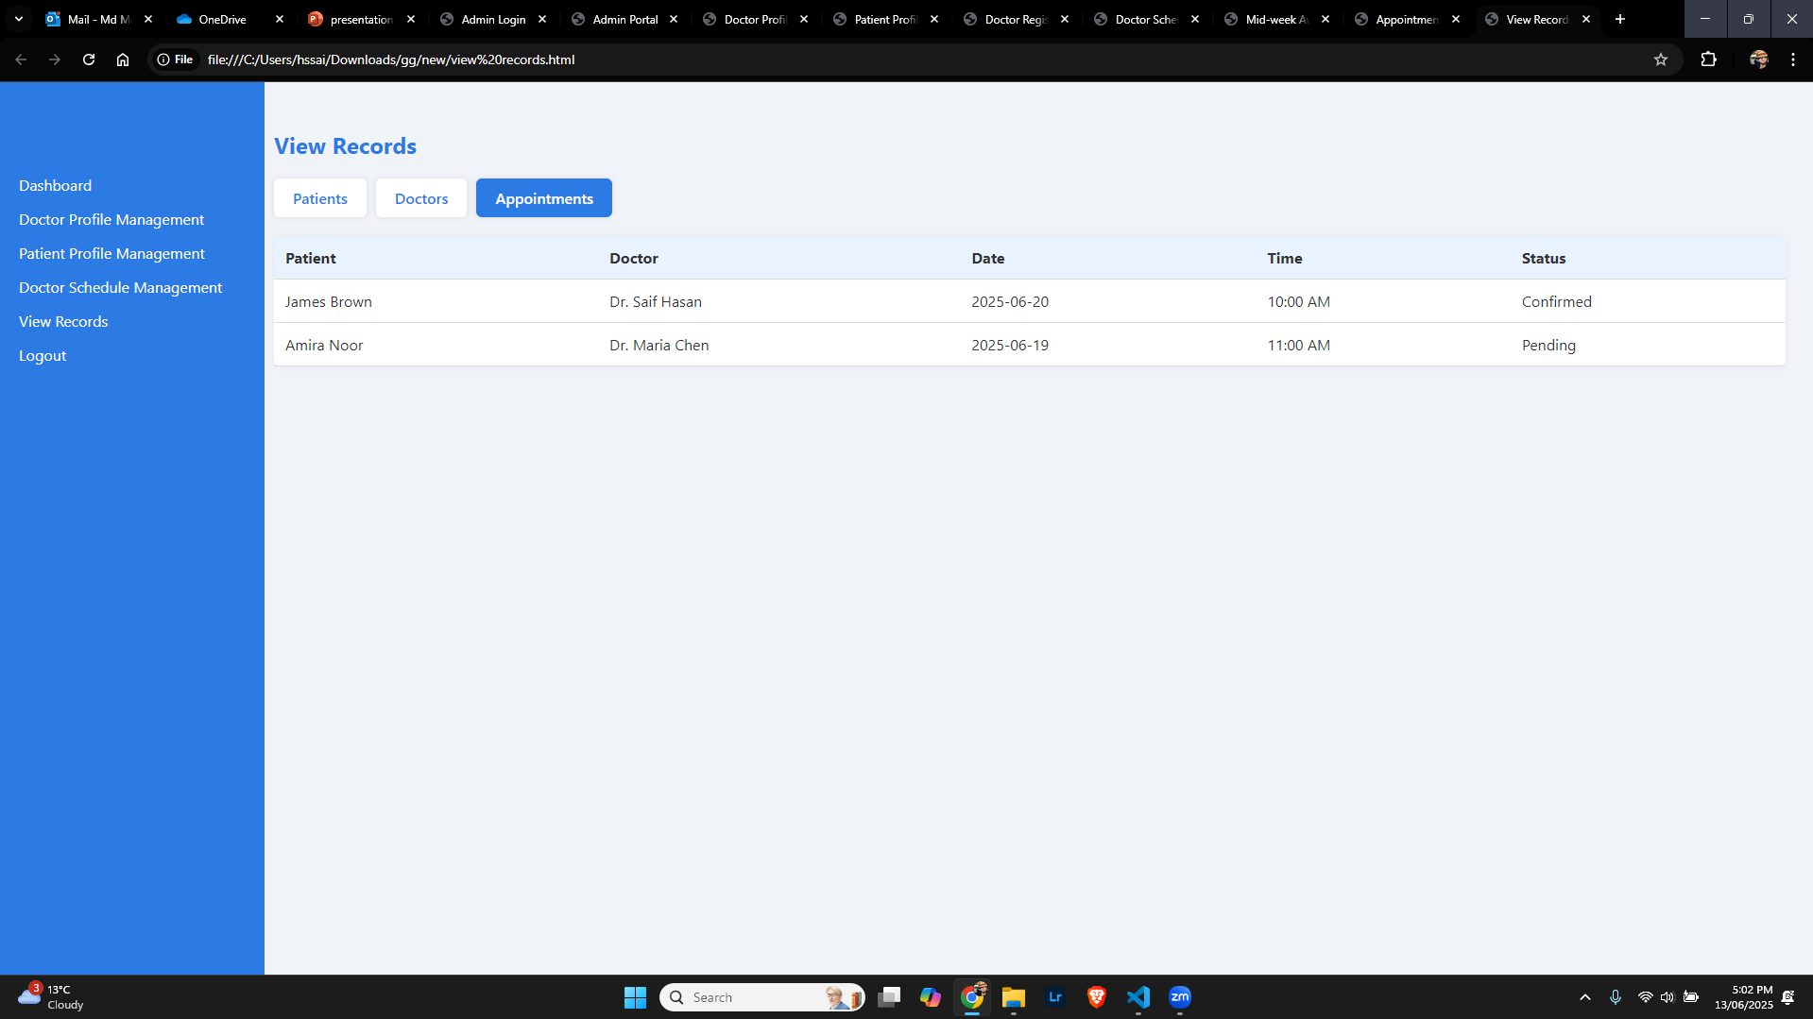

**UI design for monitor (Arnob):**

**Login Portal:**

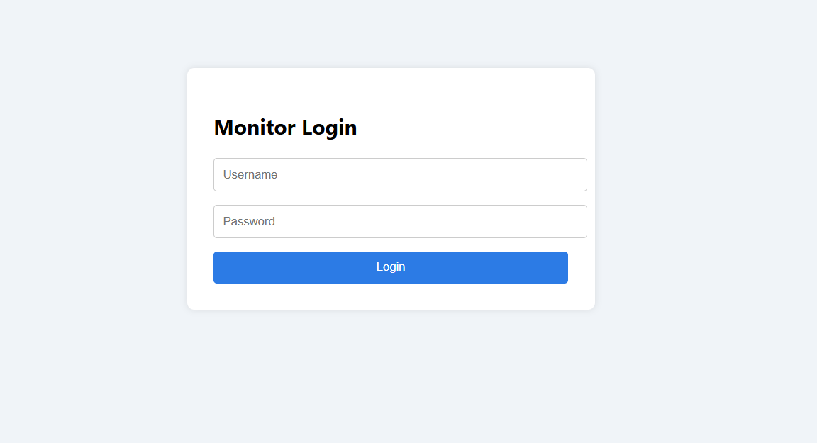

**Dashboard:**

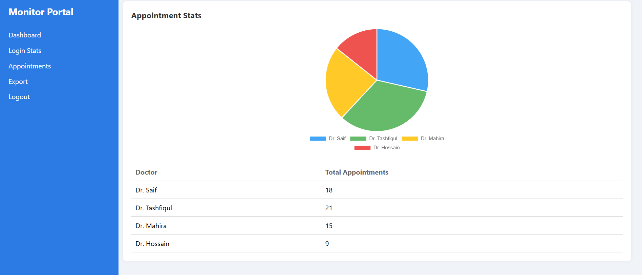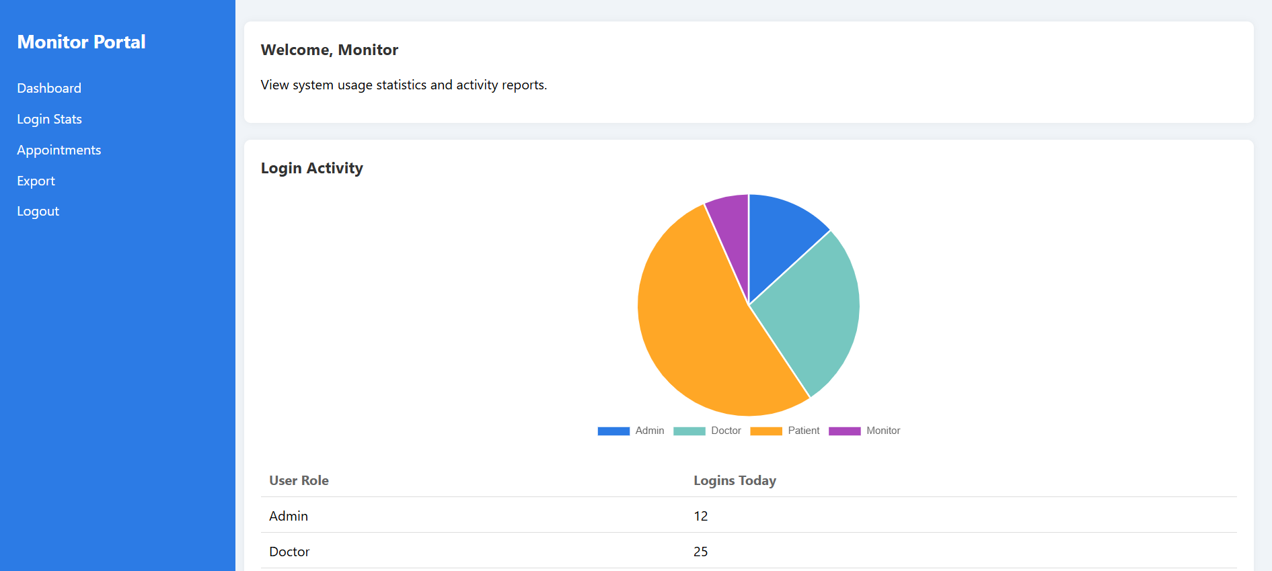

**View Patient list:**

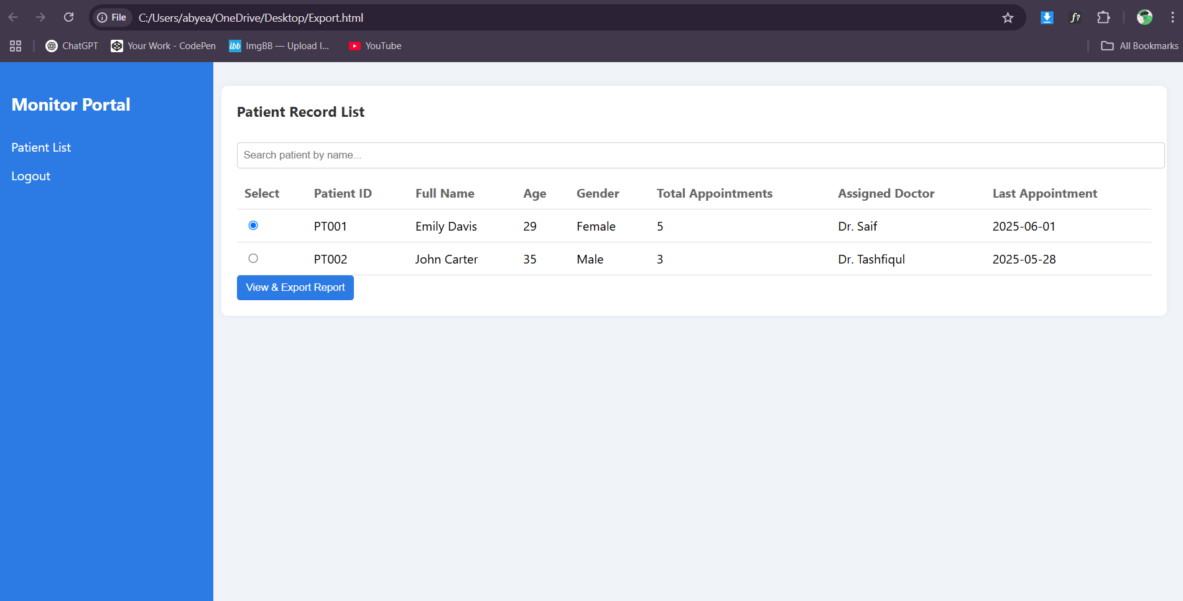

**Exprot Report:**

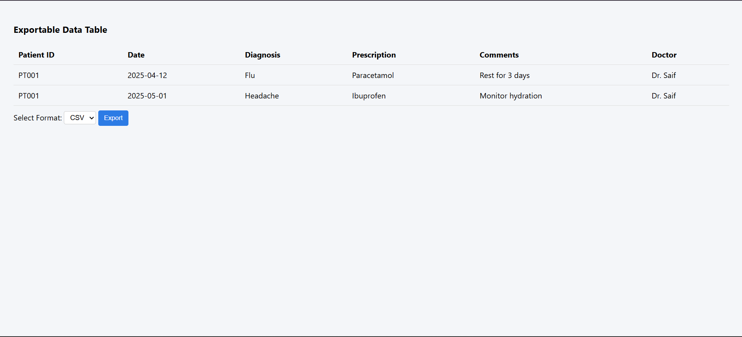

**Risk Management for MediAccessHub**

**Patient portal (Prateek):**

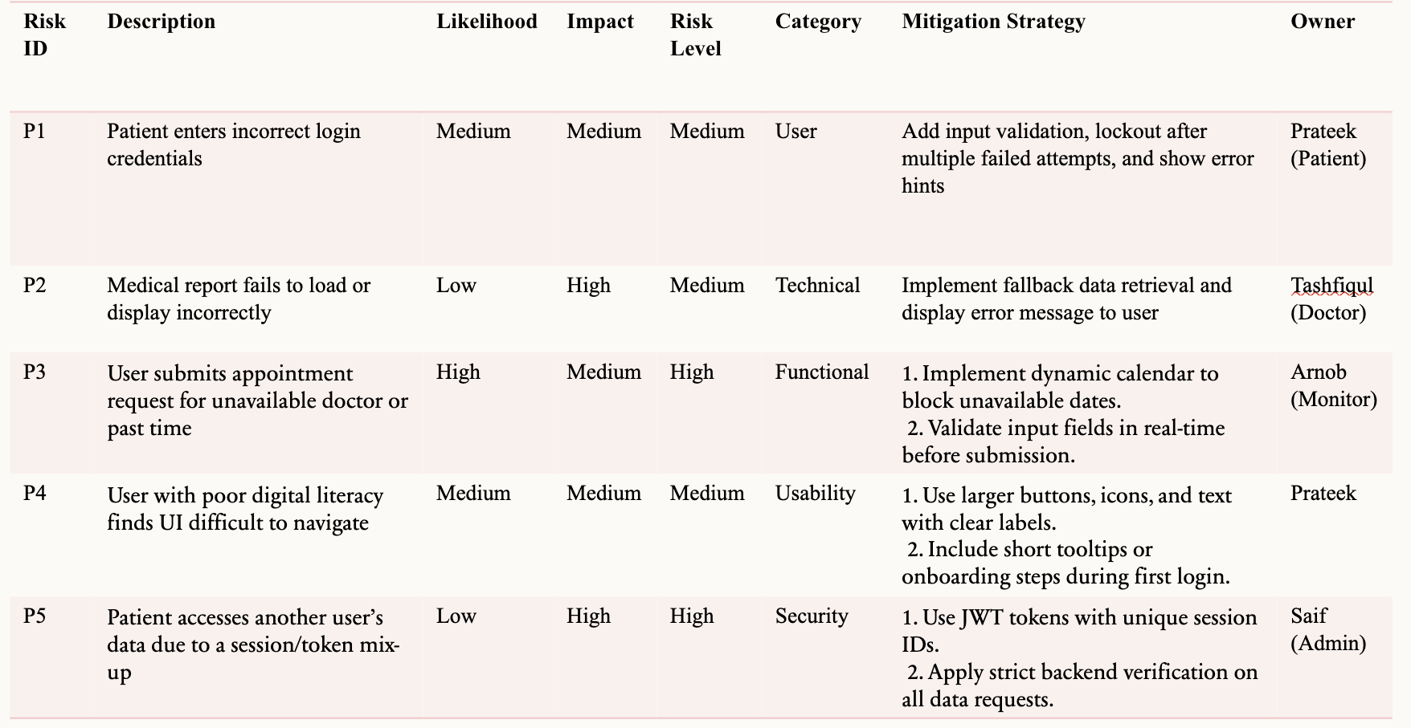

Doctor (Tashfqul)

|  |  |  |  |  |  |  |  |
| --- | --- | --- | --- | --- | --- | --- | --- |
| Risk ID | Description | Likelihood | Impact | Risk Level | Category | Mitigation Strategy | Owner |
| D1 | Doctor forgets to update availability schedule | Medium | Medium | Medium | Functional | Implement a reminder notification and visual indicator on dashboard for pending schedule updates | Doctor |
| D2 | Medical record update fails or is lost | Low | High | Medium | Technical | Use auto-save functionality, confirmation prompts, and periodic backend sync | Doctor / Dev |
| D3 | Unauthorized access to patient records | Low | High | Medium | Security | Enforce secure login, use encrypted data access, and restrict access using roles | System Admin |
| D4 | UI confusion delays doctor’s task flow | Medium | Medium | Medium | Usability | Design a minimal UI with clear call-to-action buttons and tooltips for functions | UI Designer |
| D5 | System downtime during patient check-up | Low | High | Medium | Technical | Add offline fallback (read-only), auto-reconnect messages, and sync data when online | DevOps Team |
| D6 | Doctor misidentifies patient record | Medium | High | High | User | Include patient photo, DOB, and auto-highlight active patient record in UI | Doctor |
| D7 | Missed appointment due to portal error | Low | High | Medium | Functional | Include real-time sync with appointment database and error logs; alert admin on sync issues | Developer |
| D8 | Doctor edits a record without confirmation | Medium | Medium | Medium | Usability | Add warning prompts before editing or deleting sensitive data | Developer |

**Admin (Saif):**

|  |  |  |  |  |  |  |
| --- | --- | --- | --- | --- | --- | --- |
| **Risk ID** | **Description** | **Likelihood** | **Impact** | **Risk Level** | **Mitigation Strategy** | **Owner** |
| A1 | Delay in creating Doctor schedule | Medium | High | High | Set automated reminders for admins to review availability and implement a queue management dashboard highlighting pending approvals | Saif |
| A2 | Unauthorized access attempt to the admin portal could lead to data breaches | Low | High | High | Implement two-factor authentication and strong password policies. Lock account after multiple failed attempts | Saif |
| A3 | Appointment change request pile up during peak hours | High | Medium | Medium | Assign backup admin support during peak period and auto flag urgent request for quick review | Saif |
| A4 | System fails to sync admin updates across all modules in real time | Medium | High | High | Implement auto sync services and conduct daily integration tests to catch sync issues early | Saif |
| A5 | Admin accidentally deactivates an active user | Low | Medium | Low | Add confirmation popups for deactivate actions and maintain an audit trail for recovery | Saif |

Monitor (Arnob):

|  |  |  |  |  |  |  |  |
| --- | --- | --- | --- | --- | --- | --- | --- |
| Risk ID | Description | Likelihood | Impact | Risk Level | Mitigation Strategy | Owner | Risk Category |
| M1 | Dashboard fails to update login or activity logs in real time | Medium | medium | High | Implement event-driven logging with retry logic and alerts for delays over 1 minute | Arnob | Tech. |
| M2 | Data export fails or generates corrupted files | Medium | High | High | Use reliable export libraries with data validation and error checks before download | Arnob | Tech. |
| M3 | System lags when monitoring high traffic data | High | Medium | Medium | Optimize backend queries and add server caching and use lazy loading in dahsboard views | Arnob | Tech. |
| M4 | Missing or incomplete log data due to database error | Low | High | Medium | Schedule hourly databse backups and log integrity achecks with anomaly alerts | Arnob | Tech. |
| M5 | Unauthorized access to monitoring or export functions | Low | High | High | Restrict access to specific roles and enable export logging and perform regular permission audits | Arnob | Tech. |

**TimeLine:**

# 1. NIT3003

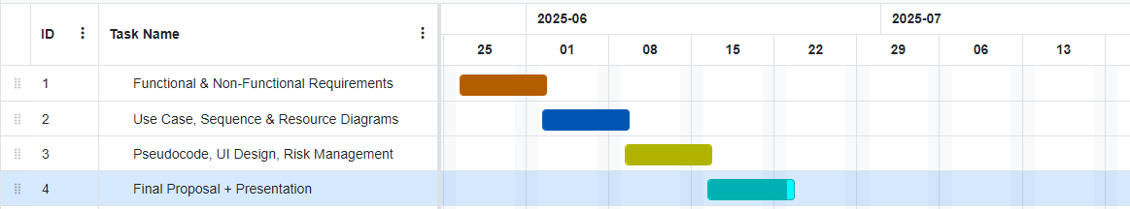

2. Implementation of 8 weeks

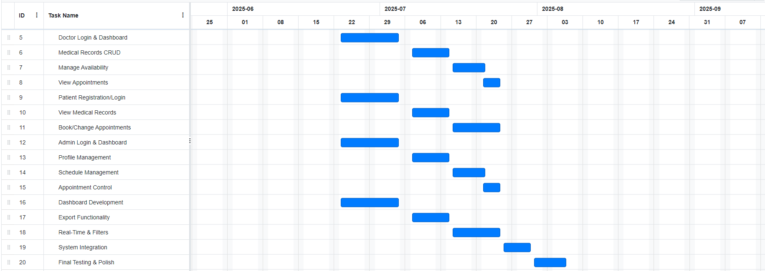

3. NIT3004

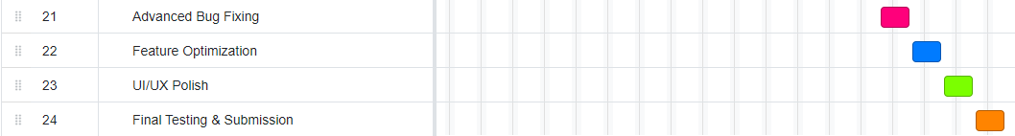

**Work Breakdown Structure:**

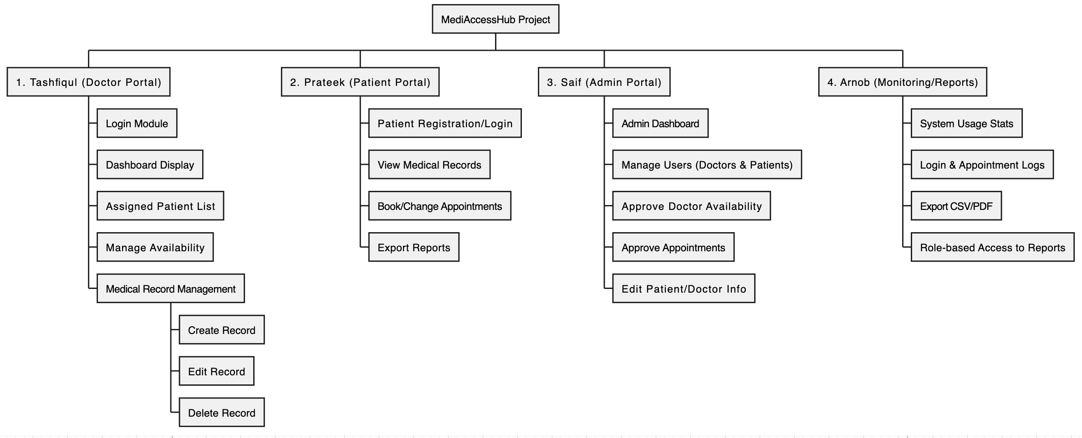

# **Conclusion:**

Our project for MediAccessHub presents a secure user friendly and comprehensive web application for managing digital medical records and booking appointments with doctors. By dividing roles across patient, doctor, admin and monitor between the team, the system ensures privacy, data integrity and smooth interaction between users. Each model for this project was thoughtfully designed to address real world healthcare challenges through a collaborative and modular approach MediAccessHub stands out as a scalable and secure platform that empowers users and improves the overall efficiency of healthcare delivery.

**Contribution:**

|  |  |  |  |
| --- | --- | --- | --- |
| **Name** | **Student ID** | **Task** | **Contribution** |
| Md Mahmudul Hasan Saif | s8089637 | Saif was responsible for Admin portal and all task related to admin portal was done by Saif as well as creating the report | 27 |
| Abyead Faisal Arnob | s8098828 | Arnob was responsible for monitor portal and all task related to monitor portal was done by Arnob and helping to create the report | 26 |
| Tashfiqul Prodhan | s8116509 | Tashfiqul was responsible for Doctor protal and all task related to doctor portal was done by tashfiqul and helping the team with group task | 25 |
| Prateek Maharjan | s8113219 | Prateek was responsible with patient portal and all task related to patient portal was done by Prateek | 22 |

# **References**

World Health Organization. (2021). Global strategy on digital health 2020–2025. <https://www.who.int/publications/i/item/9789240020924>

Fortune Business Insights. (2024). Electronic health records (EHR) market size, share & trends, 2023–2030. <https://www.fortunebusinessinsights.com/electronic-health-records-ehr-market-102798>

Australian Digital Health Agency. (2023). My Health Record system overview. <https://www.digitalhealth.gov.au/initiatives-and-programs/my-health-record>

PracticeHub. (2023). Features and solutions. [https://practicehub.com.au](https://practicehub.com.au/)

Doxy.me. (2023). Simple, free, and secure telemedicine solution. <https://doxy.me/en/>

Sommerville, I. (2016). Software engineering (10th ed.). Pearson Education. <https://books.google.com/books/about/Software_Engineering.html?id=OhL7CgAAQBAJ>